PLANT BINGO
Needle  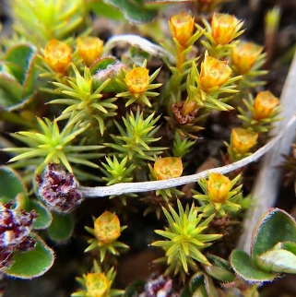  I couldn’t find any needle-bearing plants, but this looked similar. | Connation  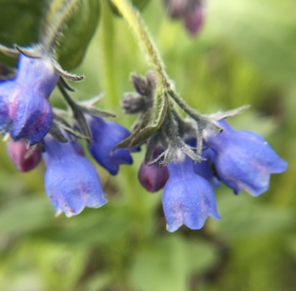 | Actinomorphic  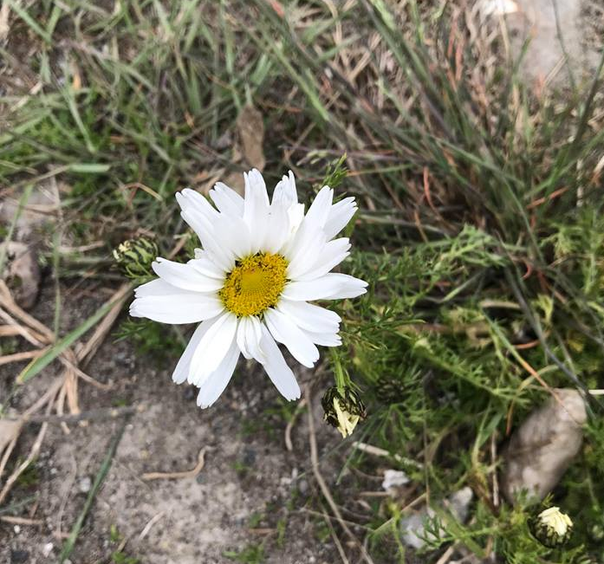
Diadelphous | Silique | Inferior ovary  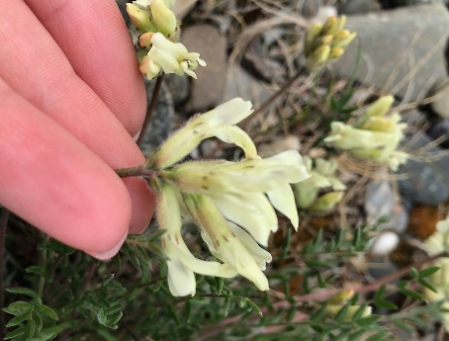
Palmate venation | Adnation | Porate anther dehiscence- I couldn’t find this kind of dehiscence, but I did find longitudinal anther dehiscence!

