PLANT BINGO

Needle  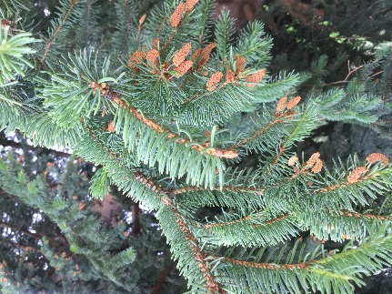 | Connation  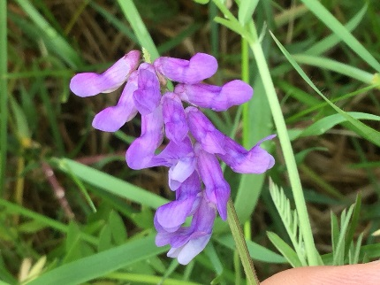 | Actinomorphic  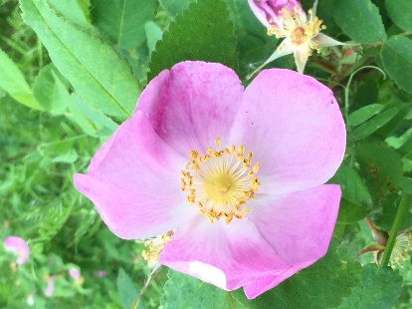
Diadelphous  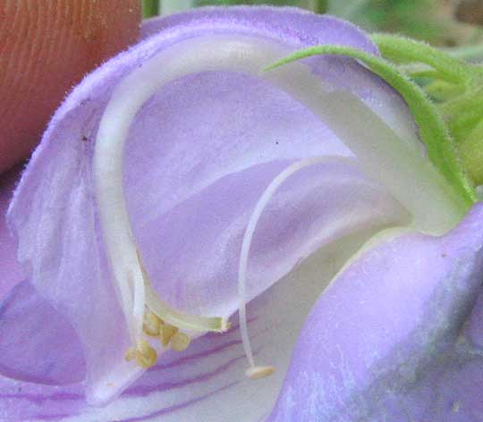  I was unable to find this in the plants I saw so this is an internet photo. | Silique  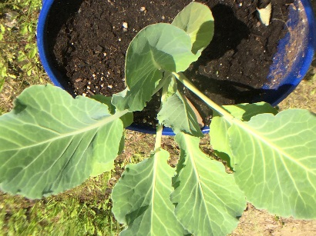  Cabbage (It is still in its new stages of growing) | Inferior ovary  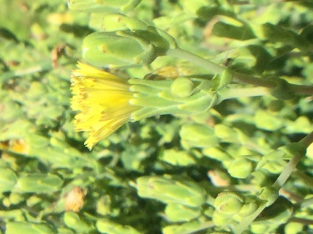
Palmate venation––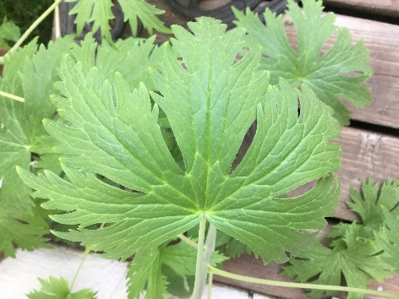 | Adnation  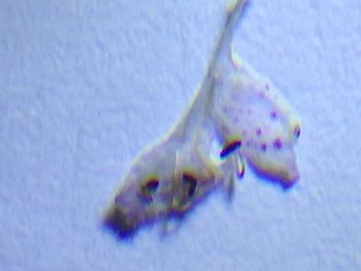  I know it’s really hard to see, but this is a petal of a catnip flower where the anthers are attached to the petal. | Porate anther dehiscence  