Genovese Basil or Ocimum basilicum is a culinary herb of the Lamiaceae family
Found growing along greenhouse in Fairbanks Alaska. Annual
Apical bud with vegetative shooting
Small buds shown
Leaf is blade shaped and 4cm
Petioles shown well
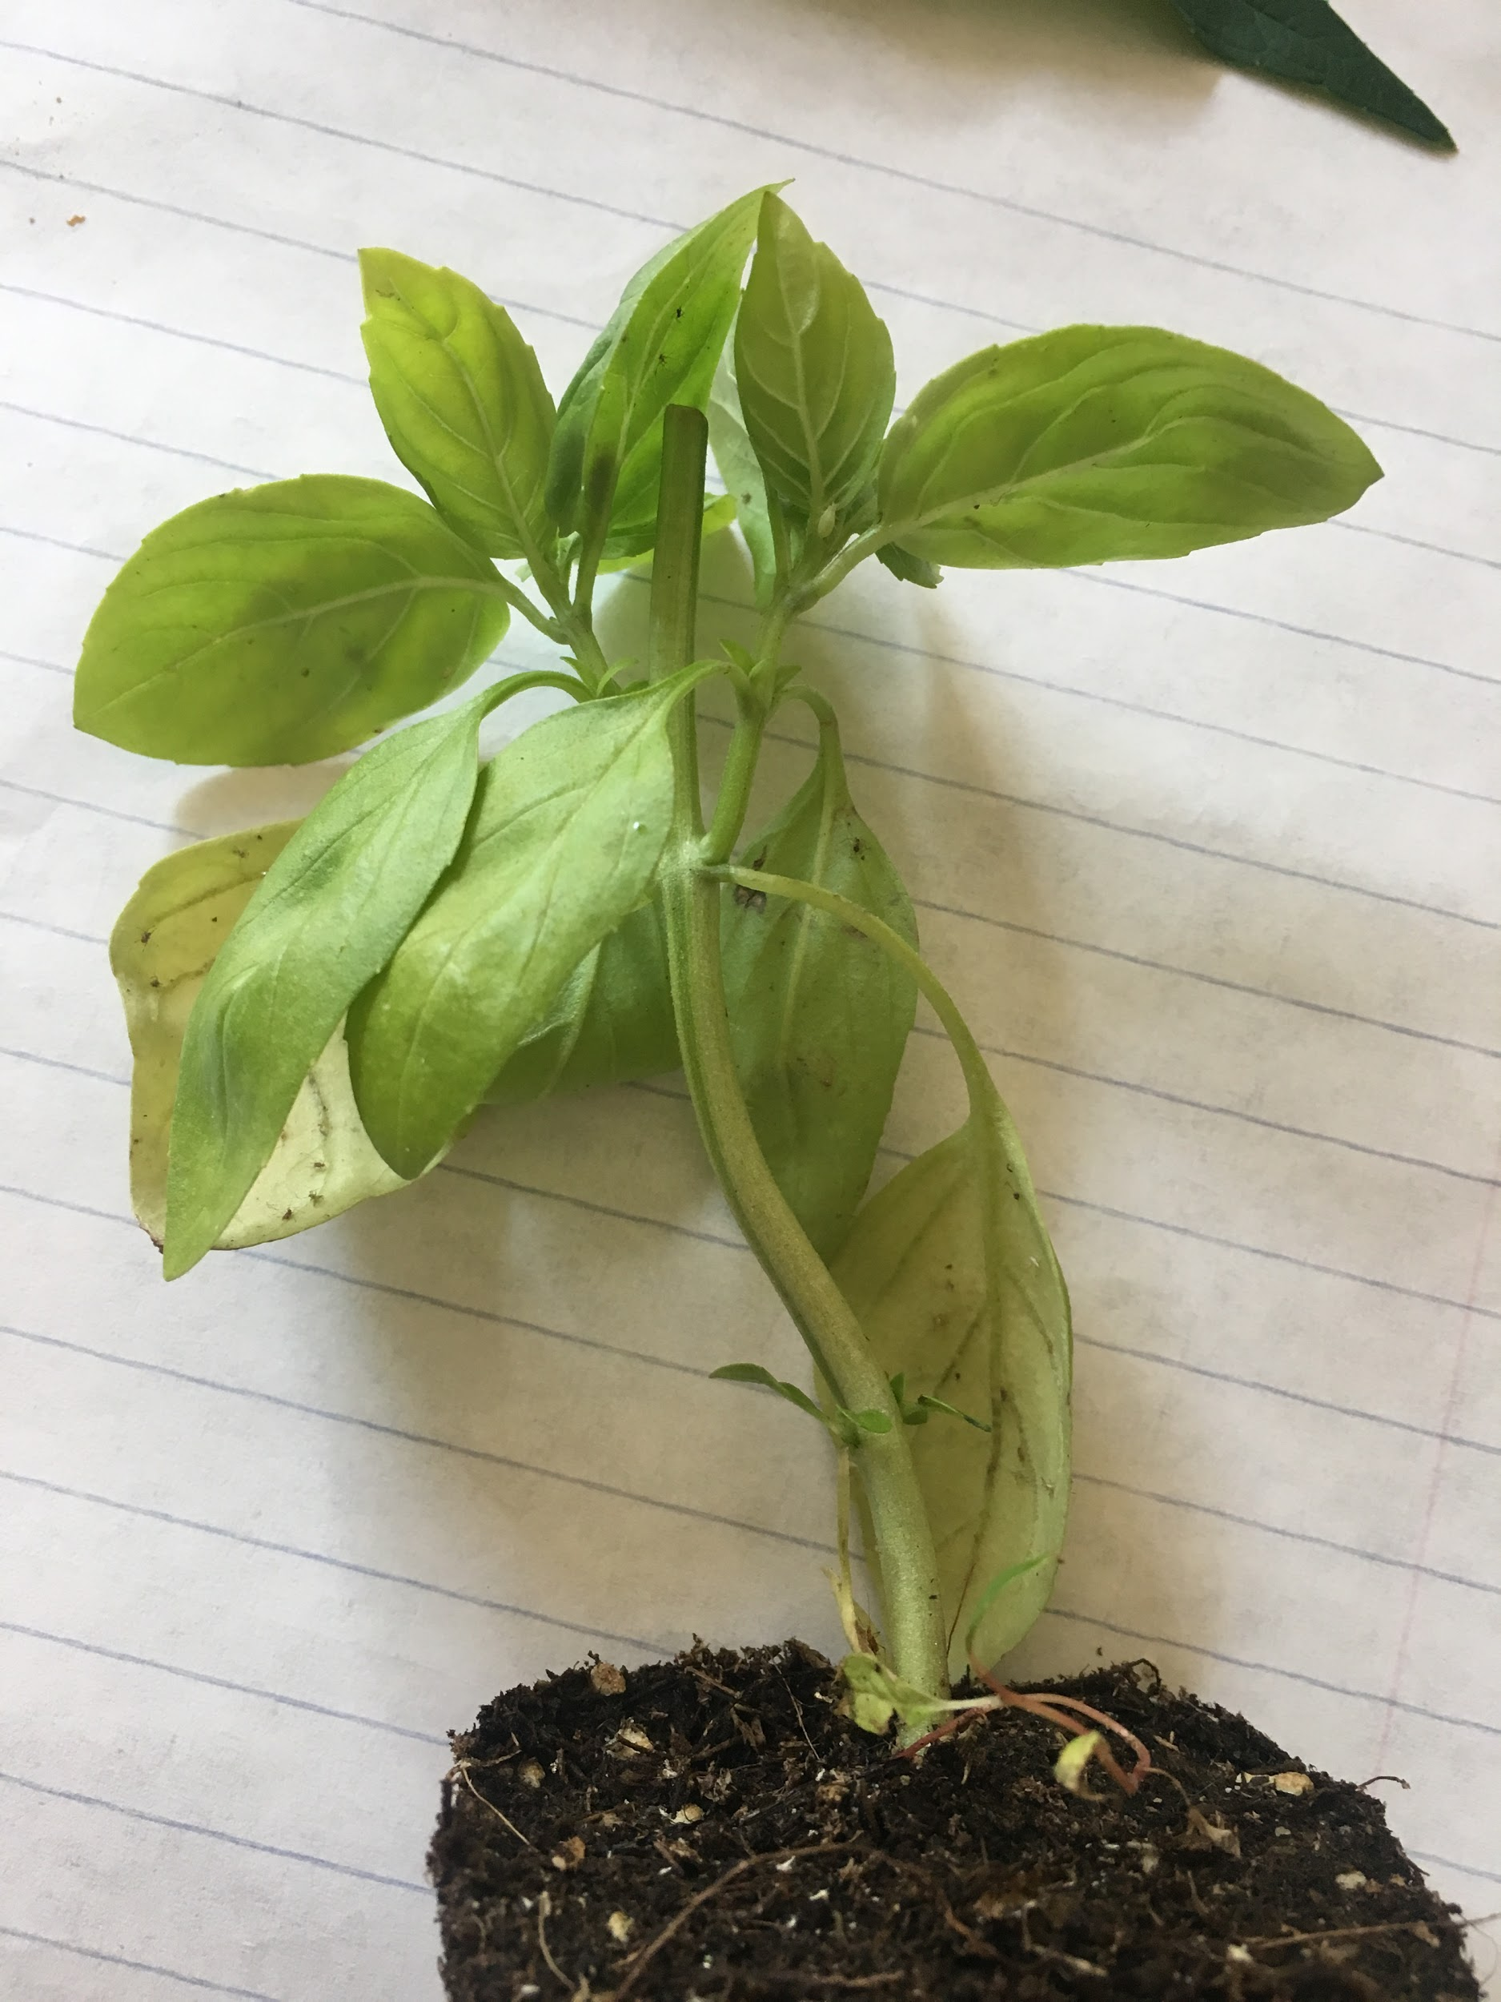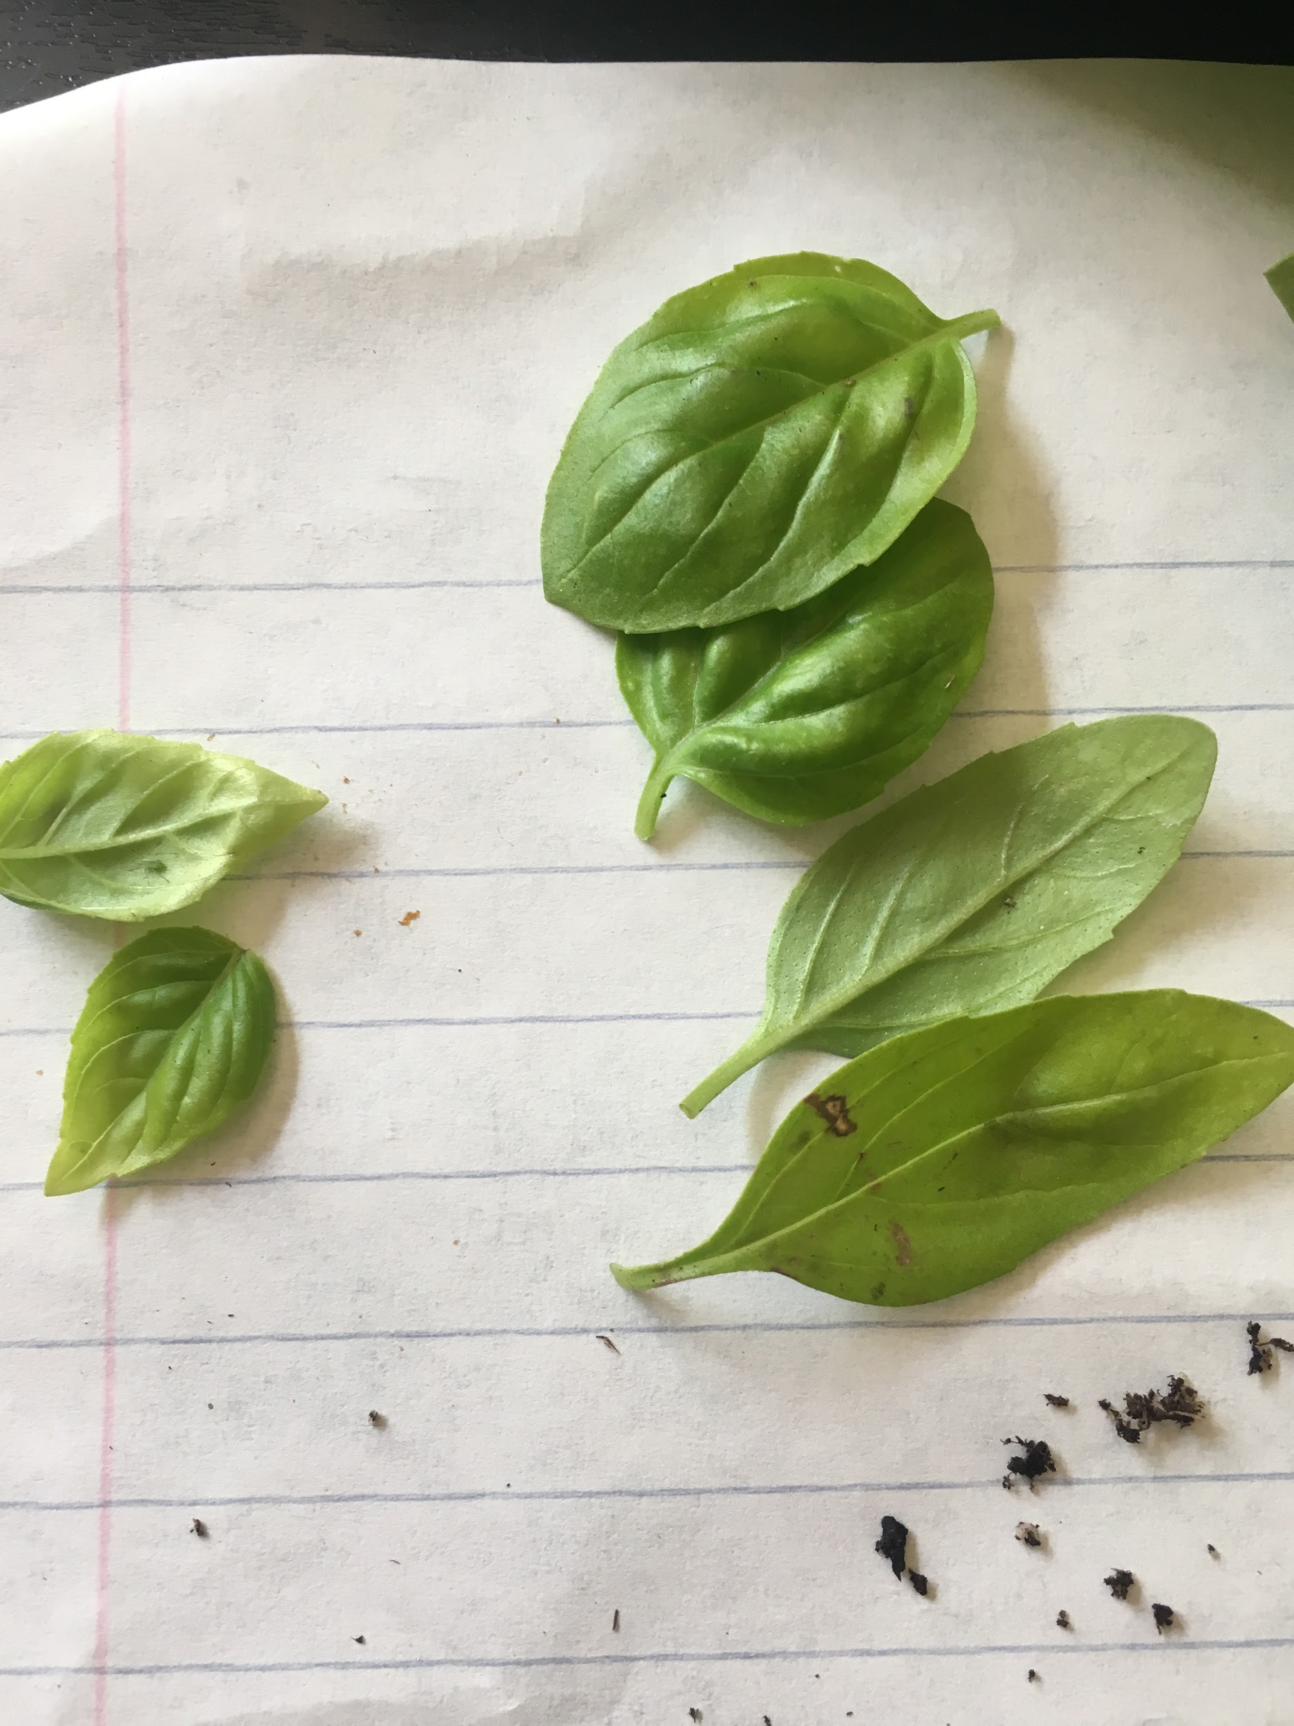
Axillary buds, nodes and internodes. Cordage secondary leaves and ovate primary.
Primary and lateral root
Stem
Pinnately veined leaves 