FireWeed a perennial Herbaceous. Part of the Onagraceae family. Found growing along the river bed near Chena River, Fairbanks Alaska. The plant has Rhizomatous roots. Can rang from 1ft to 4ft in height. This specimens is 19 inches.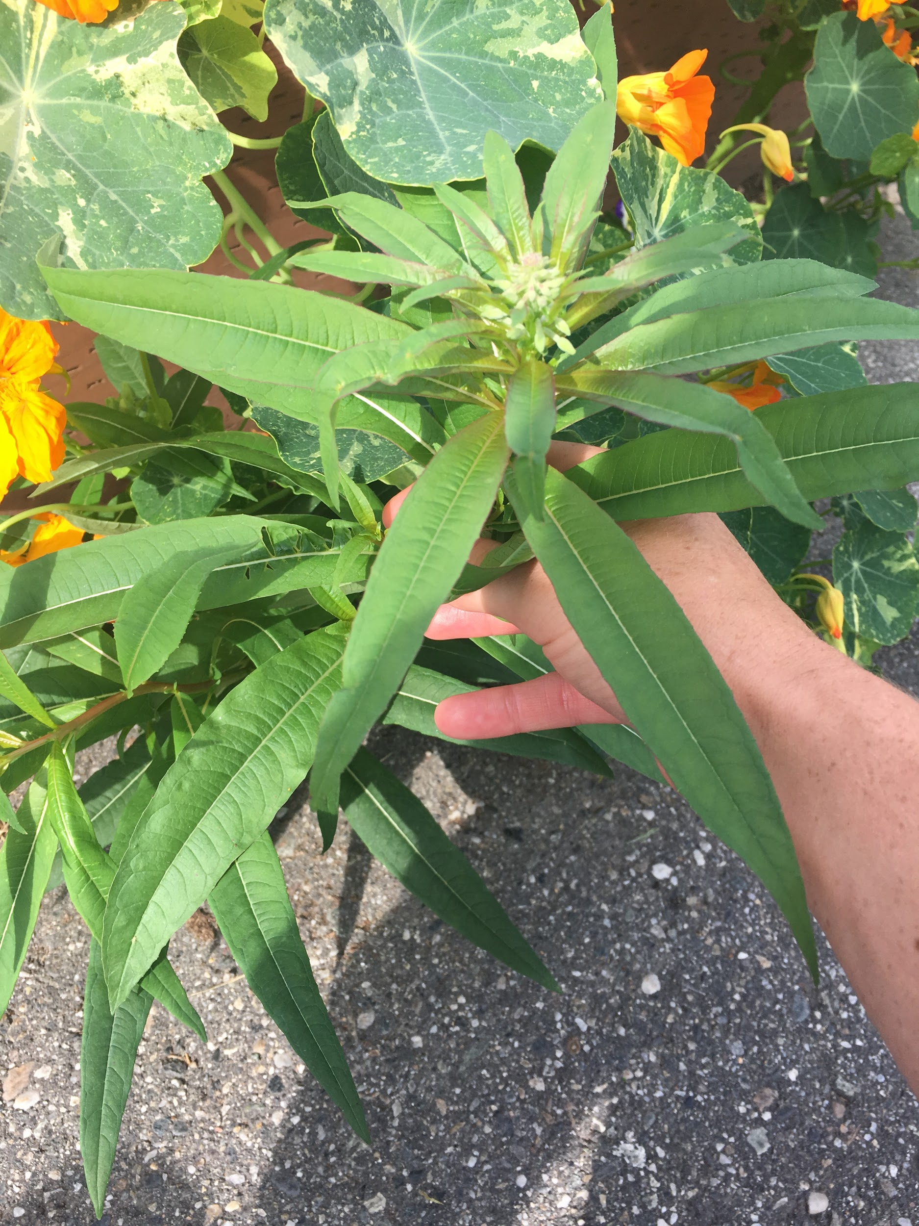
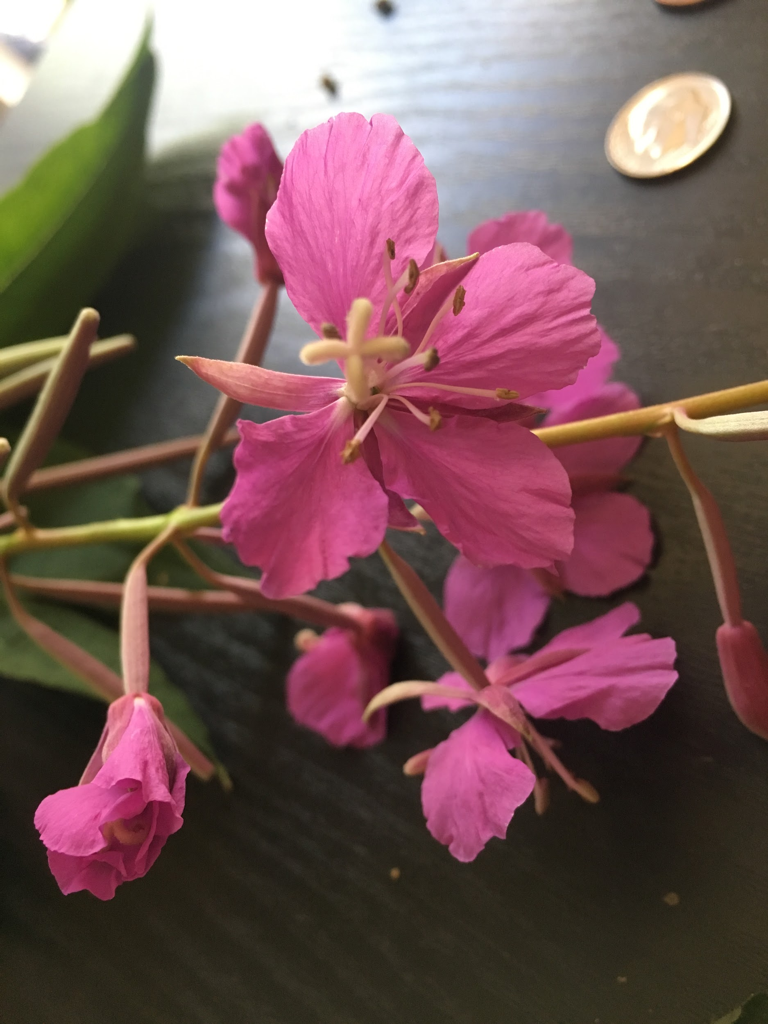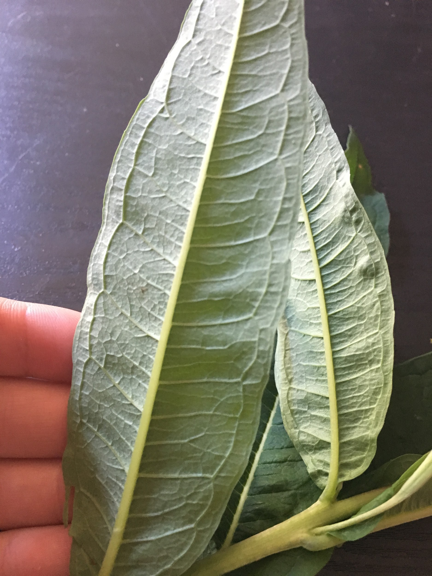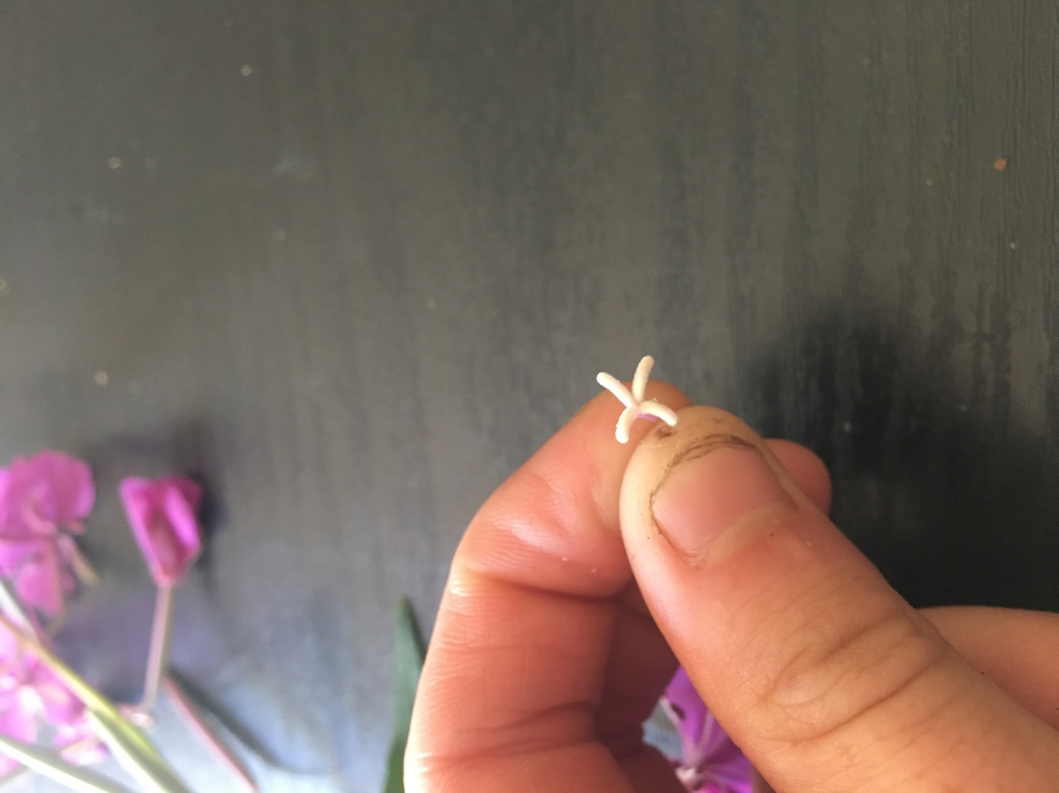

8 stamens, 4 sepals, and 4 petals and pistil. The petals are lanceolate. Inferior ovary is longitudinal. The inflorescence is a raceme with obviate petals. 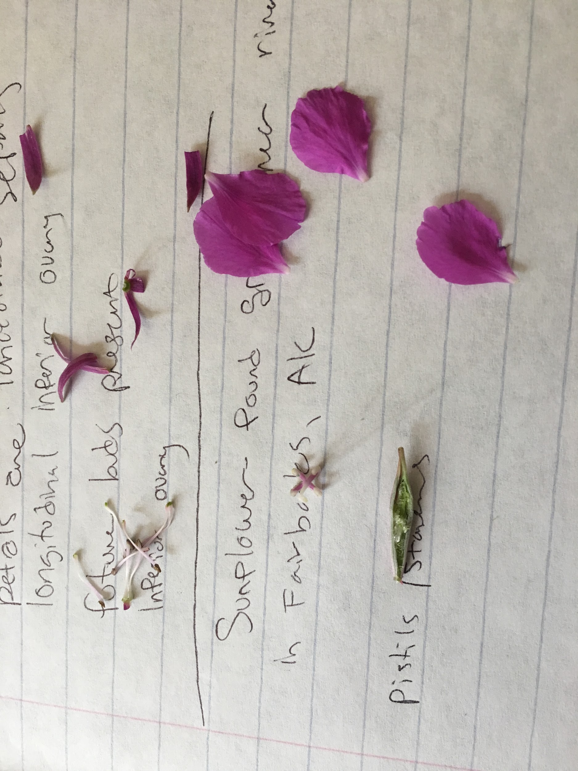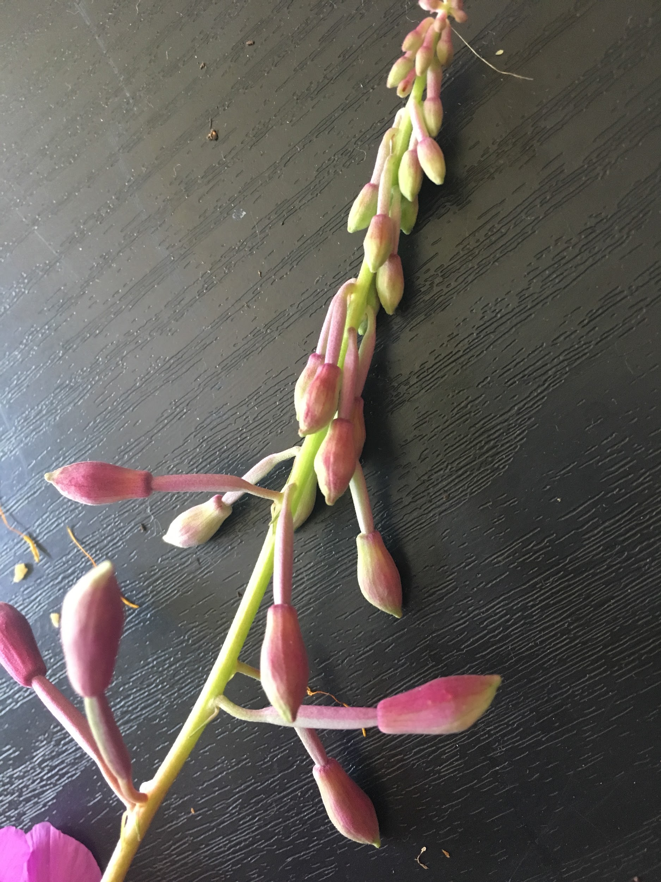The lower plant displays pinnate leaves with veins. 