Ledum paulstre Ericaceae (Labrador tea)  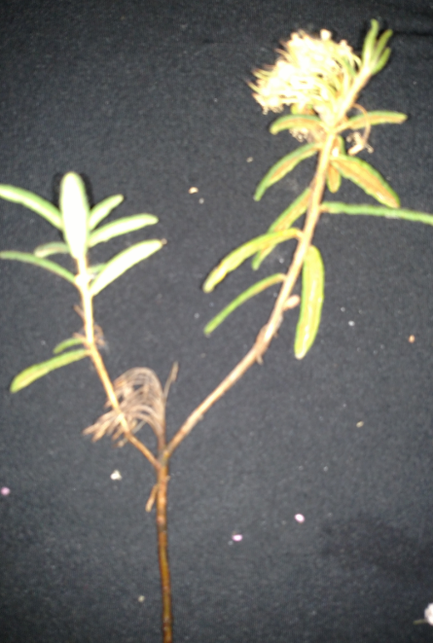 | Upper Leaf, narrow lanceolate  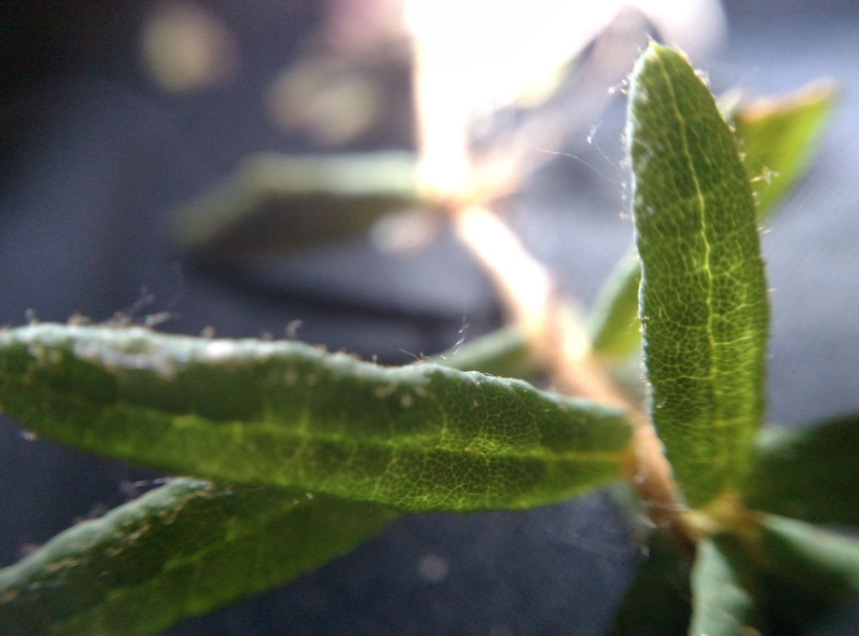 | Cluster flower heads dried  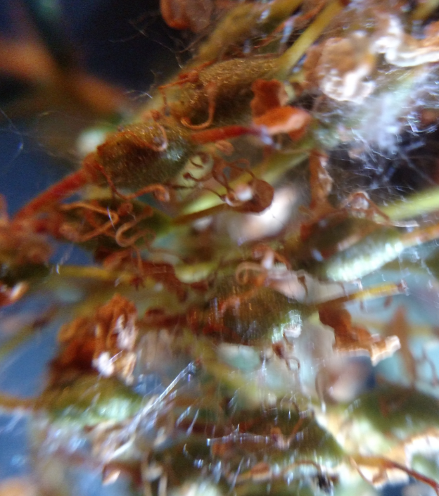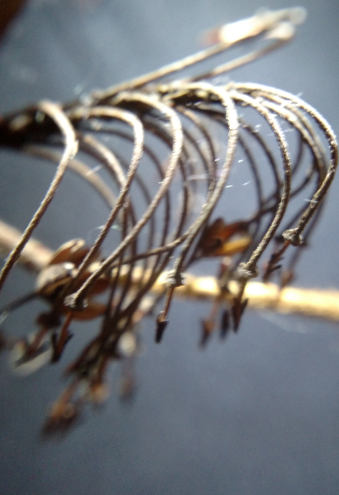
single small flower retrieved from http://www.ediblewildfood.com/Labrador-tea.aspx  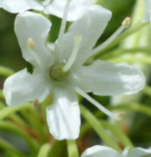 | Underside of leaf, rust colored, wooly  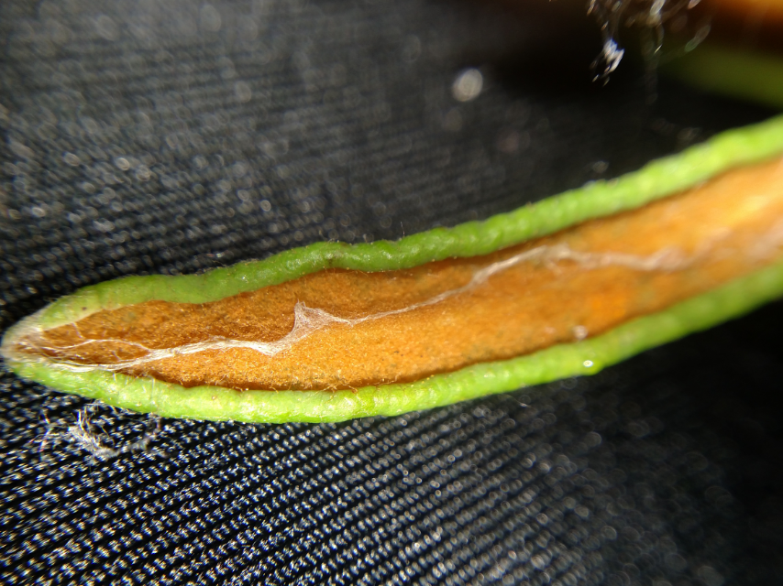 | Leaves measured parts  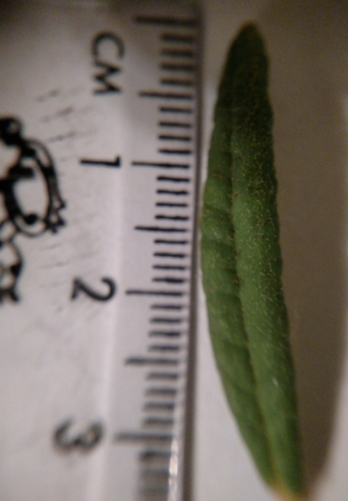
Note: the flowers were not present at this time of year on the Labrador tea in Anchorage on Muldoon Road and Northern Lights Blvd at a local park/trail, so I included a single flower picture from Edible Wild Food webpage, retrieved 7/14/19. | Teens looking at plants with Optivisor  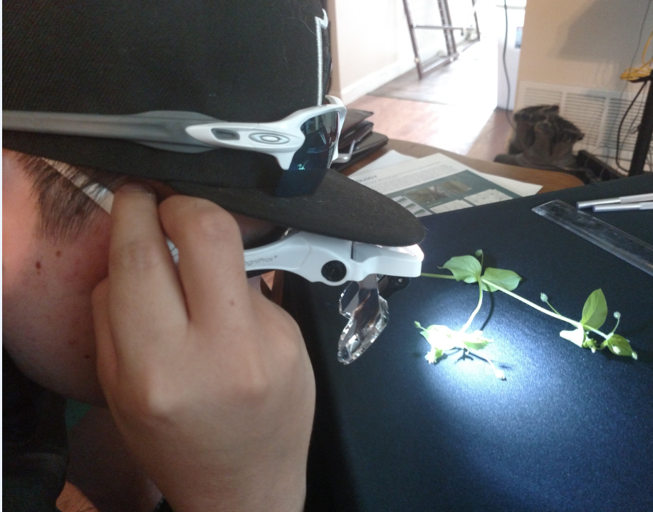 | Common in tundra and bogs, evergreen shrub, woody stem, alternate lance shaped leaves, wooly rusty underside, cluster flower head, white petals ~1 cm across, 5-7 stamens, rhizomatous

