needle  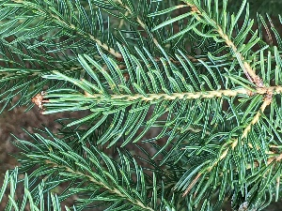 | connation 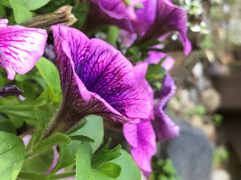 | actinomorphic  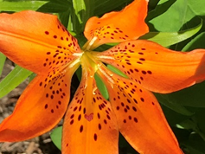 Tiger Lily
Diadelphous  (didn’t find any nearby, but will update if any are located) | silique 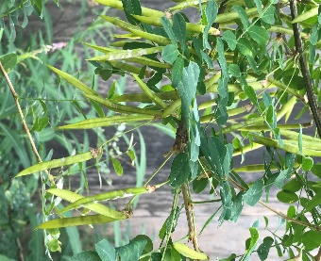 | inferior ovary  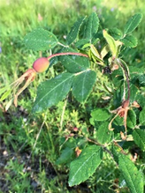 Wild Prickly Rose
palmate venation  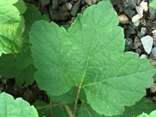 | Adnation  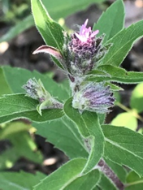 I haven’t identified this plant yet but two entire flowers seem to be basally fused to the whorled leaves. | porate anther dehiscence 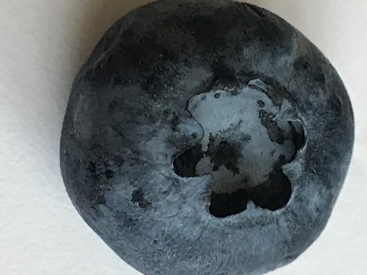Blueberry
PLANT BINGO Maggie VS Biol F195 July 2019

