Rhubarb plant in the genus Rheum Polygonaceae family. Found growing along the Chena river at the Princess Lodge in Fairbanks Alaska. 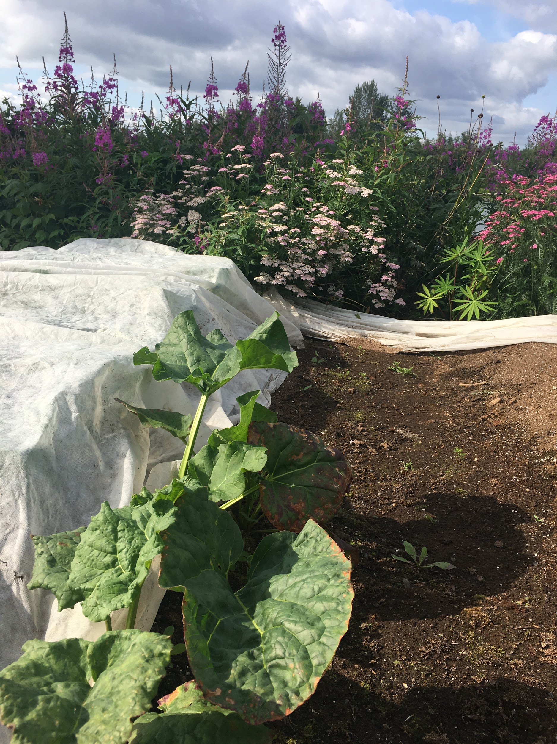Herbaceous Perennial. Small scale habitat with plant height of 16 inches. Rhizomes form along leaves with very large petioles. The leaves are elongated and heart shaped.
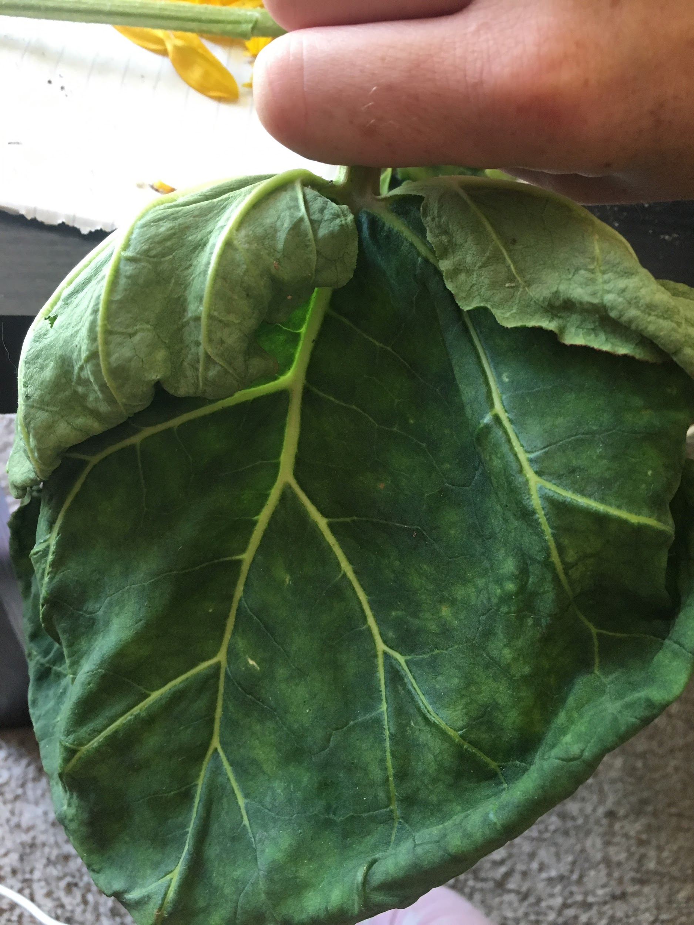 Similar to concordats shape in the leaves with very present veins. Palmate leaves. Venation Leaves start or begin their life on large petioles or the stalk of the leaf. Plant has not produced flowers or fruits containing seeds yet. Premature flowers.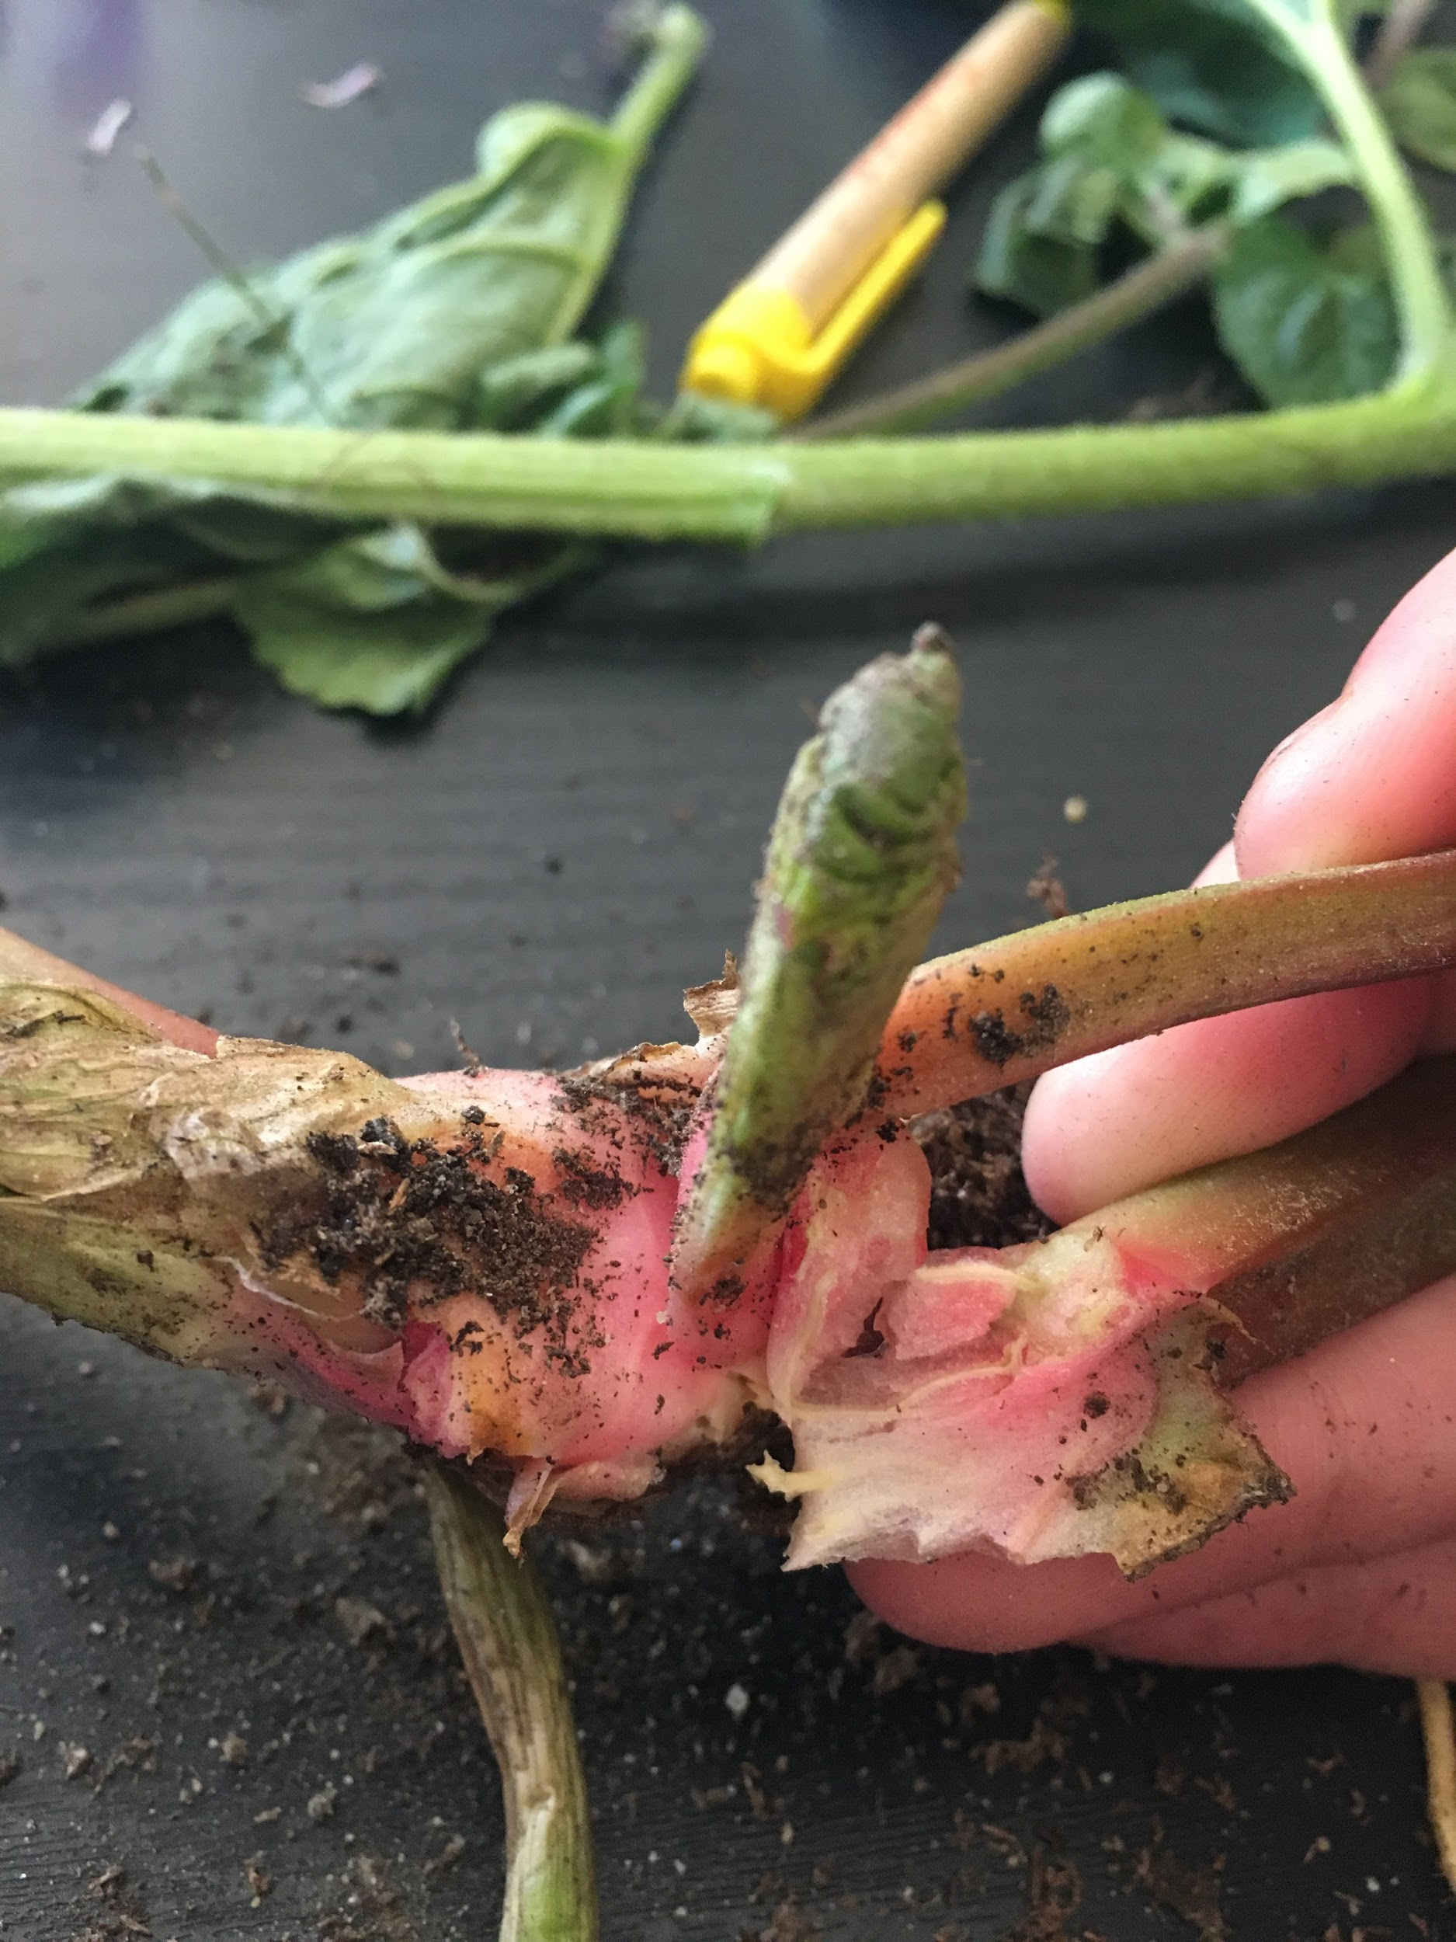 Root hairs, root can, and root. Meristem shown. Can view epidermis of root system. Root nodules or tubercles shown. Primary and secondary root. Root branch also displayed near epidermis of root. 