Sunflower or Asteraceae Family with inflorescence of Ray florets that appear similar to petals shapes. Found growing along greenhouse at the Princess Hotel Lodge in Fairbanks Alaska. Small scale habitat. About 3ft and 4 inches.
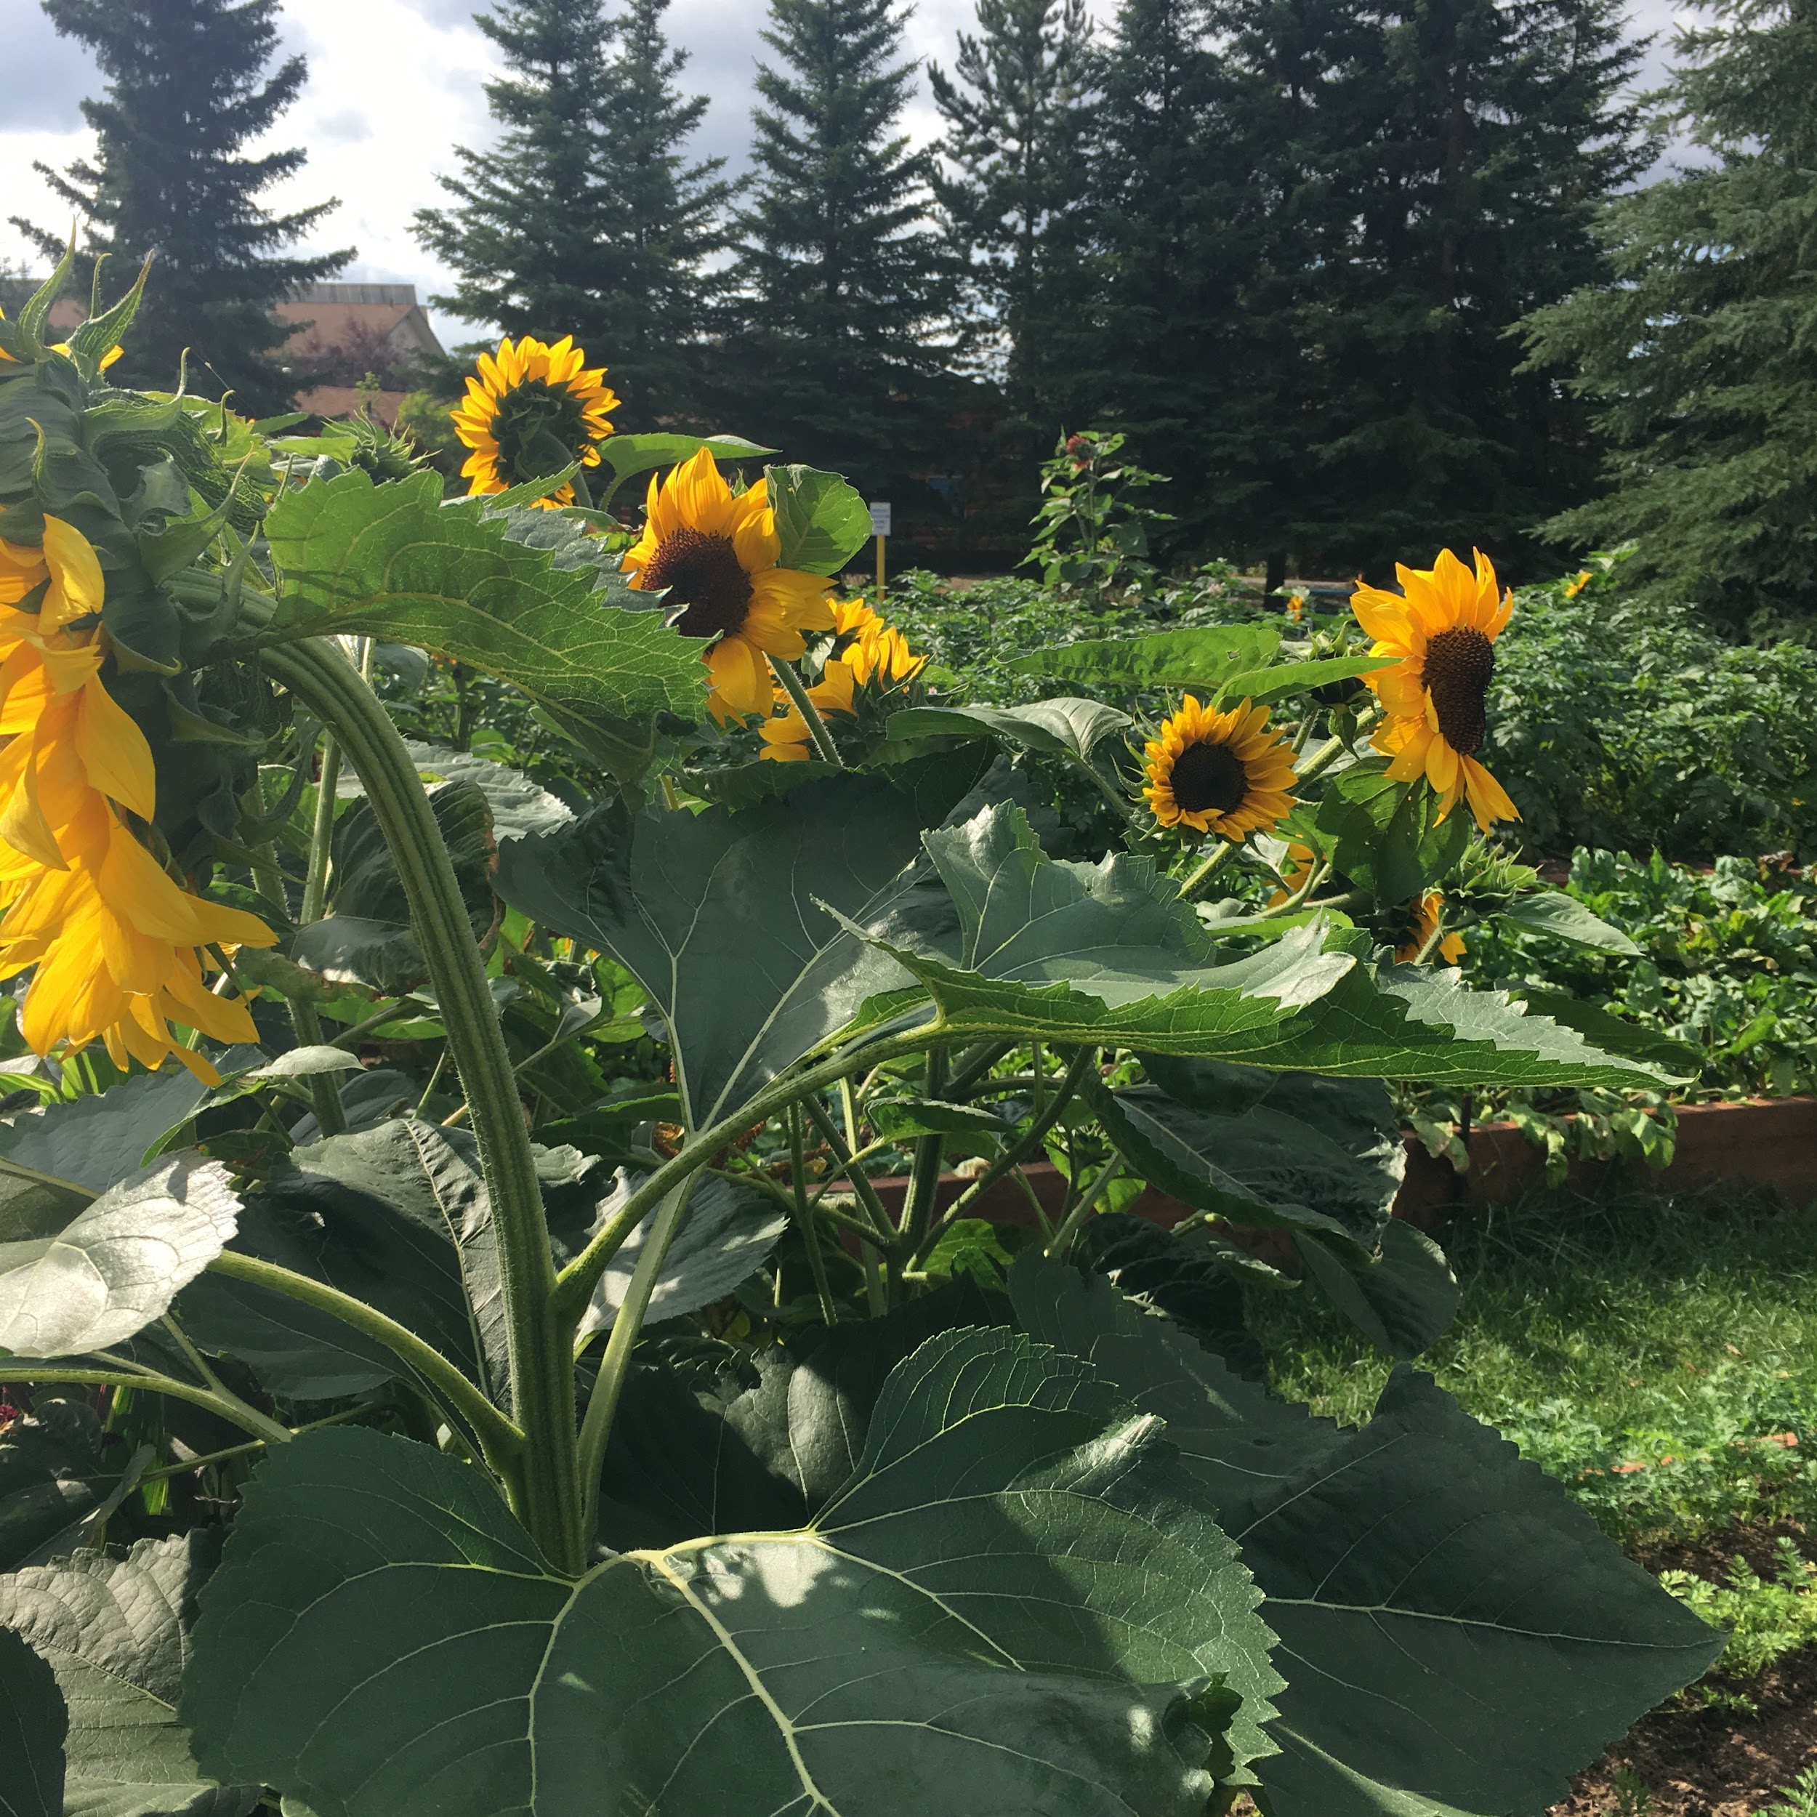

flower accompanied by disc florets form the head of the flower. One pistil. Premature bud shown. 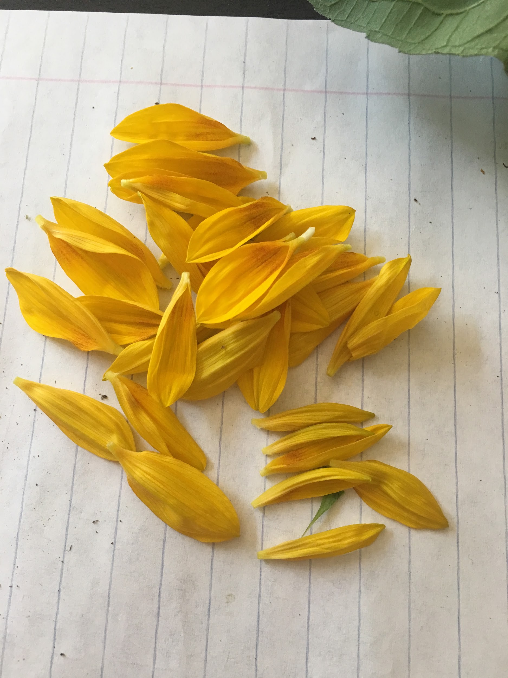Ray Flower has 34 petals shown above
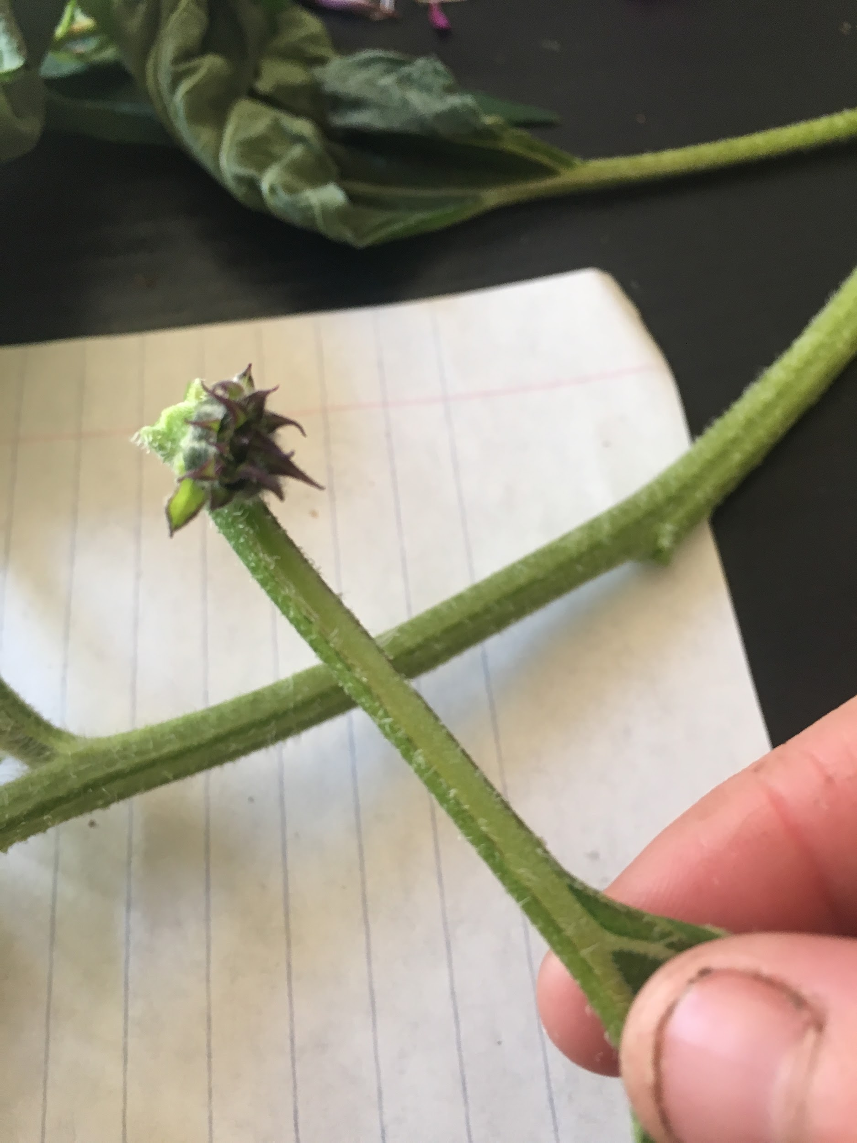
Premature bud along stem. Nodes and internodes shown
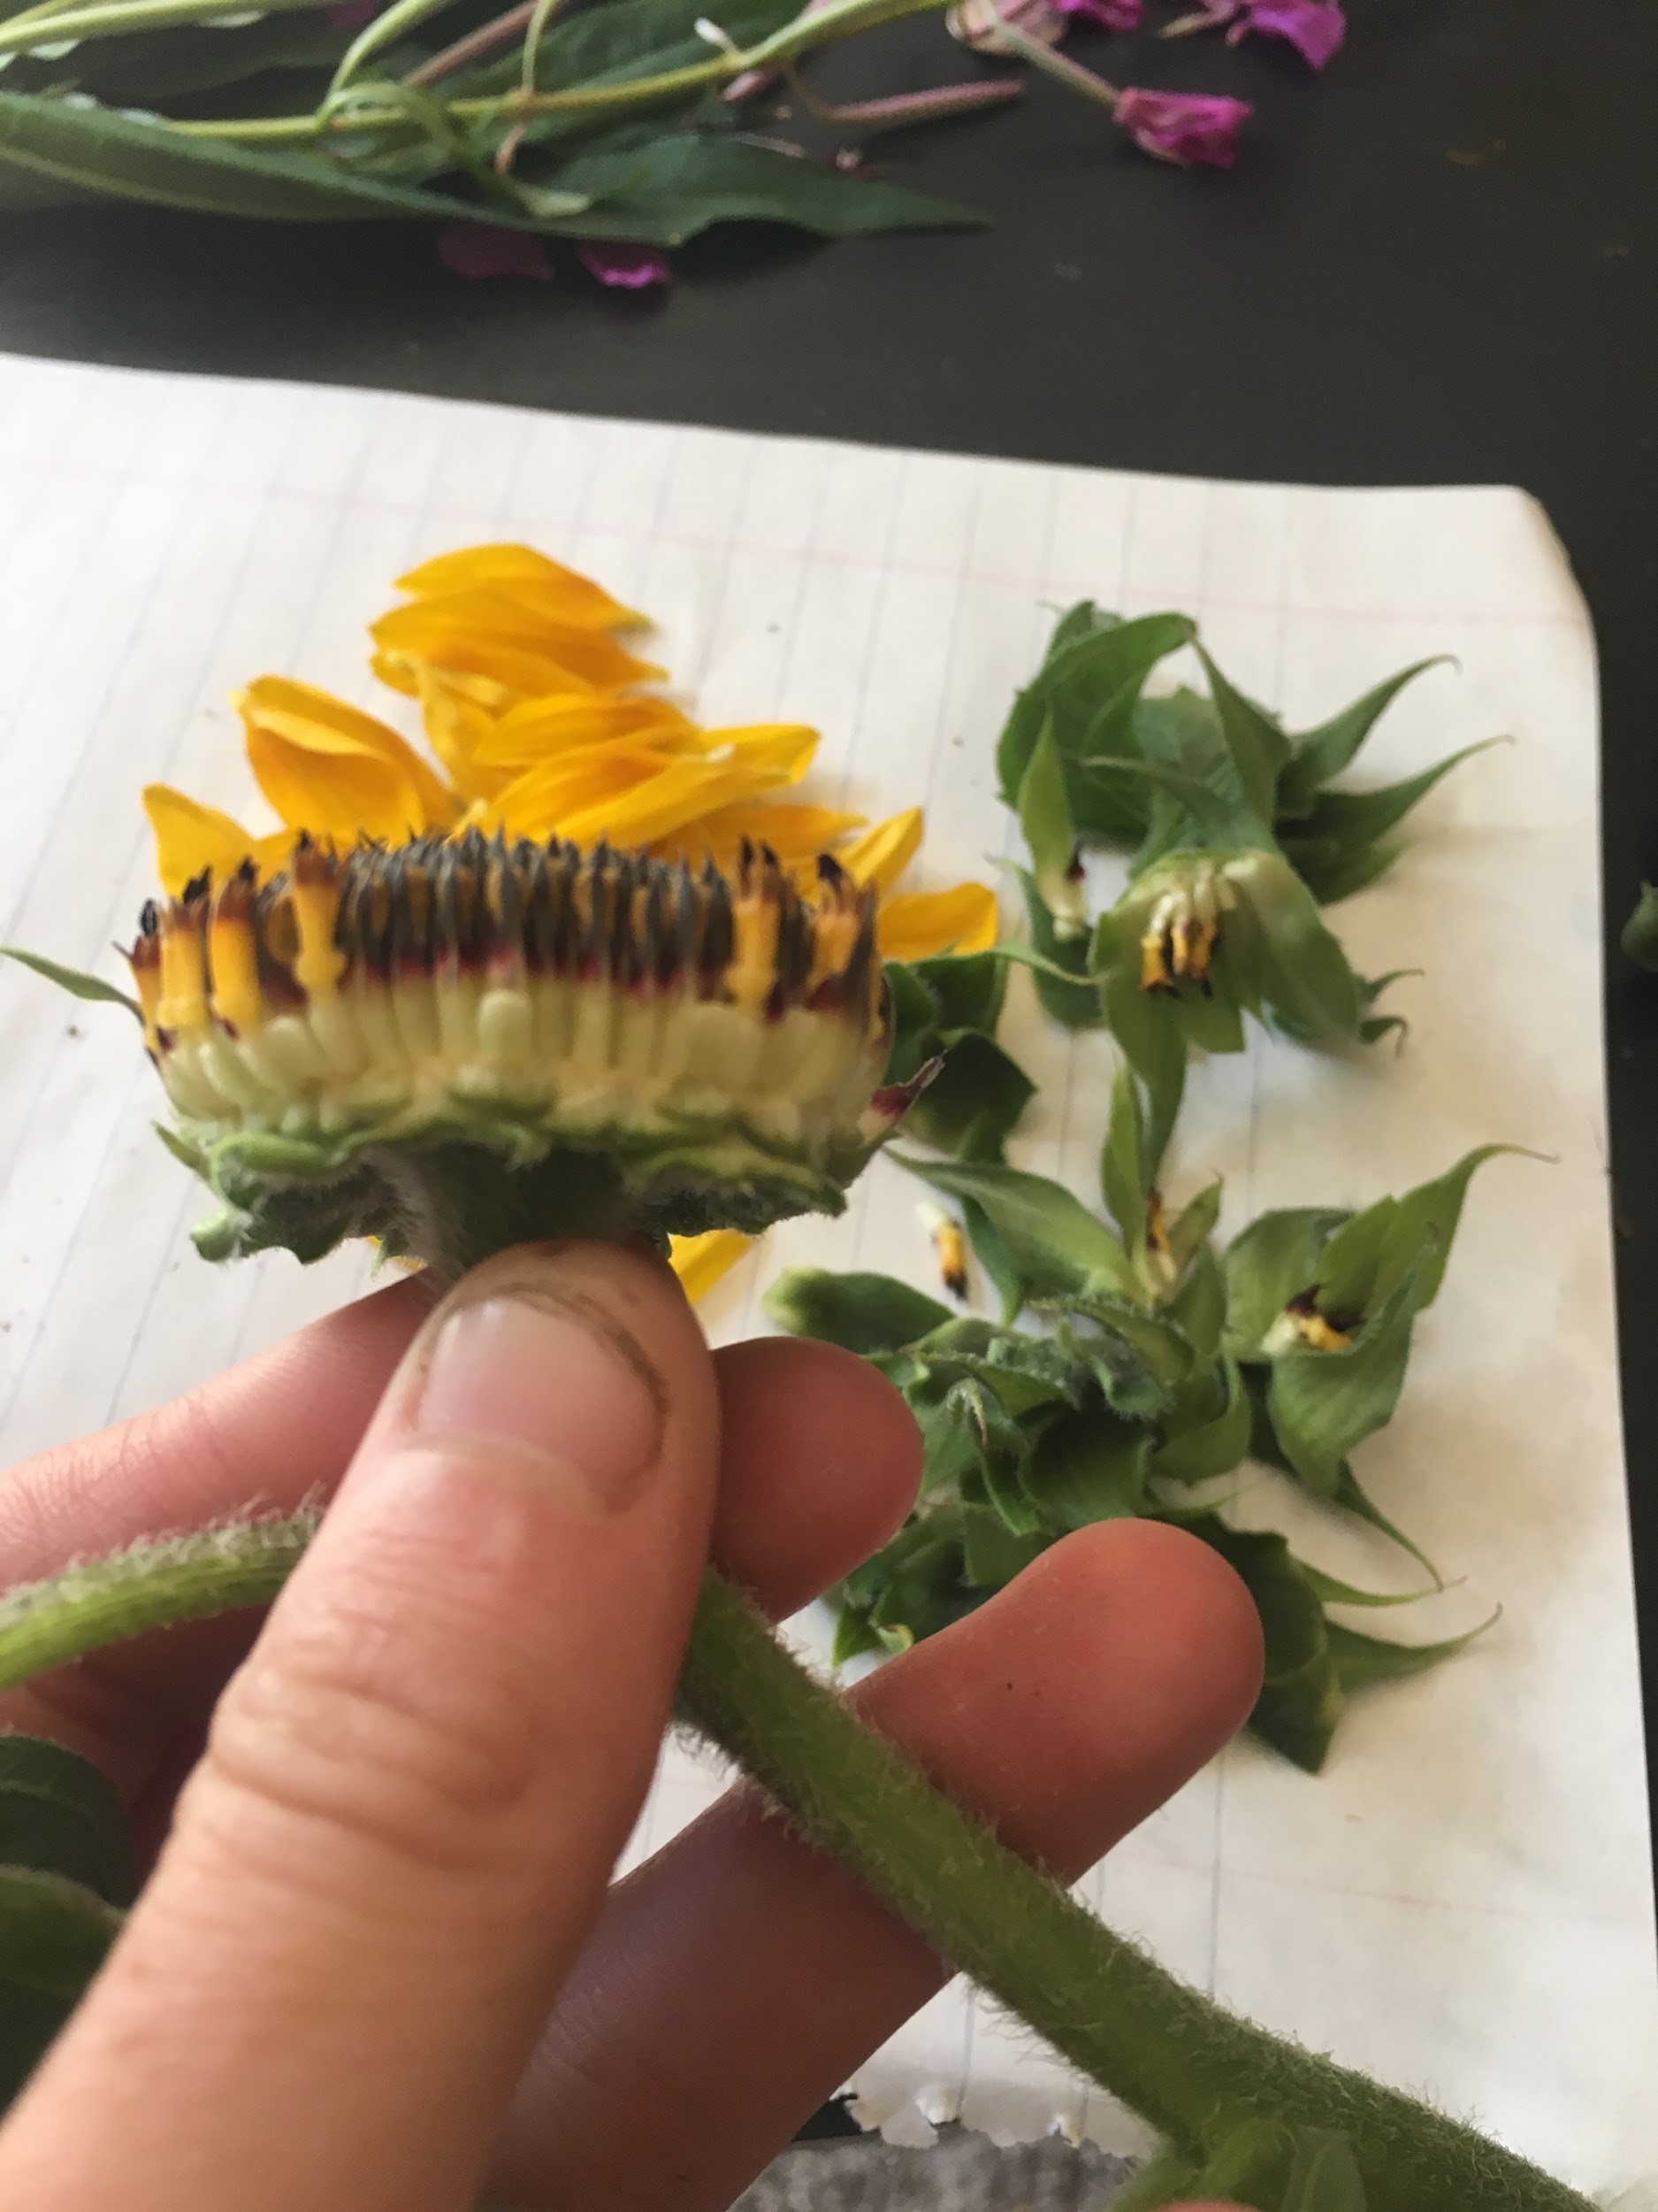
Sunflower has a capitulum head or ovary.
Receptacle scale shown.
Disc Floret.
Ovary, with two stigma and style within singular pistil. Stamen displays anther and filament.
Bract phyllary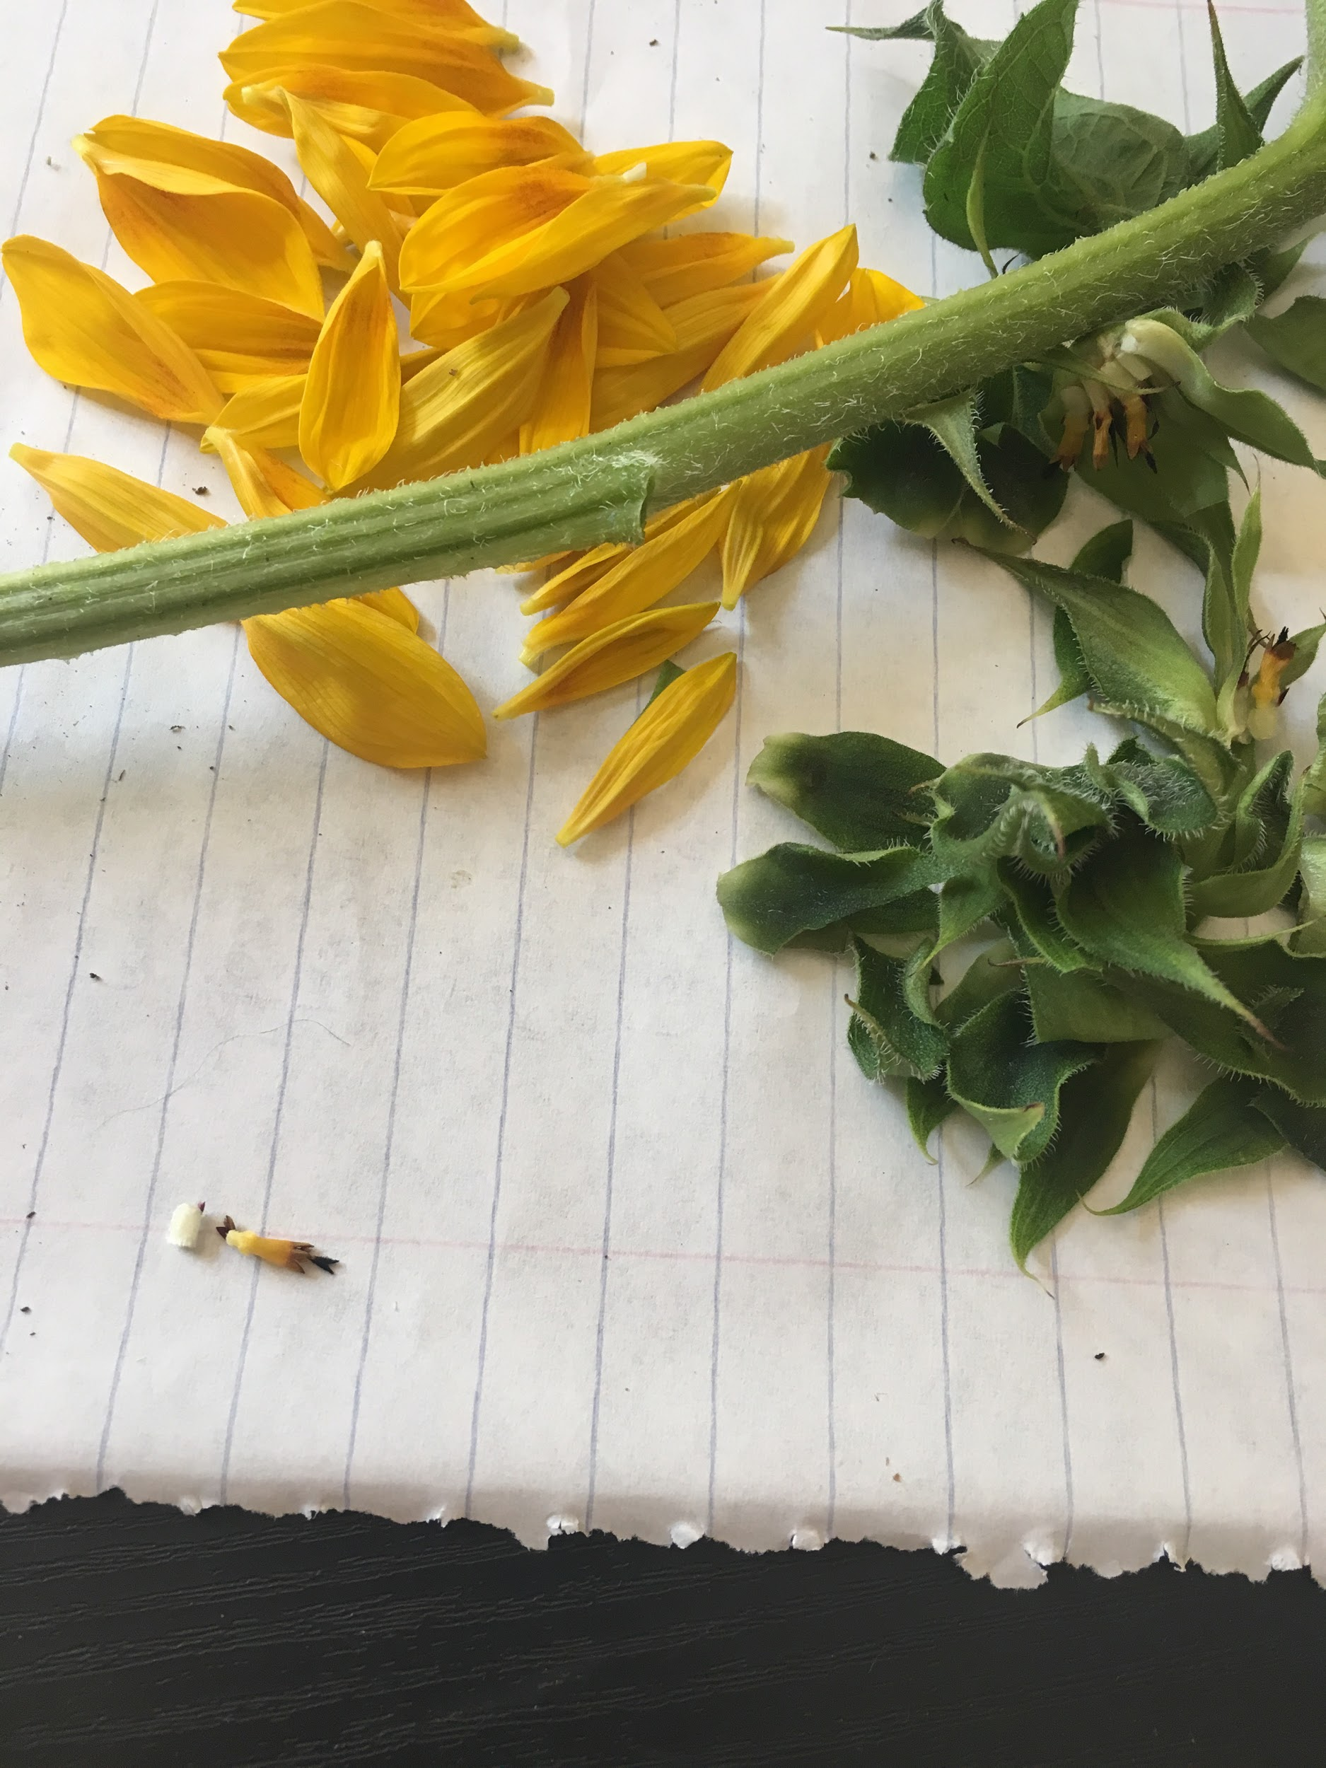
Ovary of disk flower and corolla
Overy of ray flower and corolla of ray flower

