Family: Rosaceae, subfamily Rosoidae
Specimen: Fragaria x ananassa Dichesne., garden strawberry, cultivar "Charlotte"
https://www.thinglink.com/scene/1340813362816090114

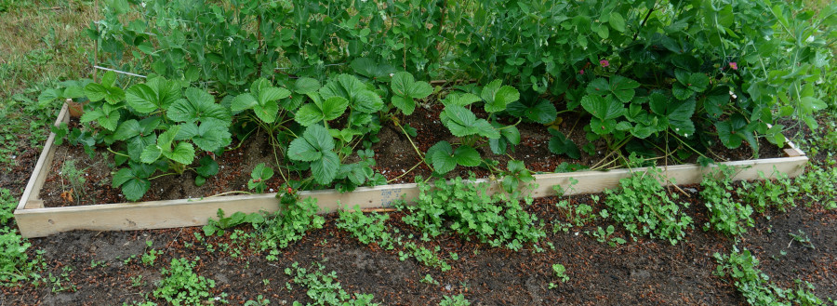

Habitat: Herbaceous cultivar. Perennial. Popular food crop.

Vegetative Parts
  - Leaves trifoliate, compound palmately, pinnate venation, dentately toothed except at base; dark green on top with trichomes, light green under and pubescent; stems pubescent; stipulate. Stolons present, pubescent. Roots fibrous, adventitious off the stolons.

Top of compound leaf; note sparsely distributed trichomes

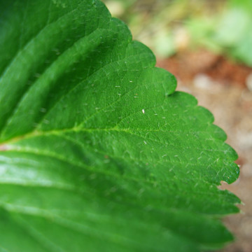
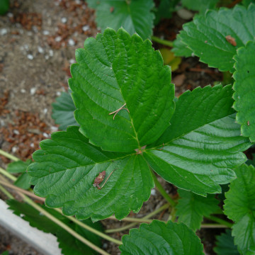

Underside of leaf; hairs barely visible on leaf, visible on rachis and petiole

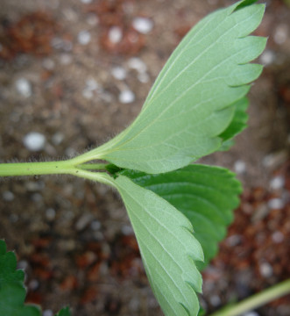

End of stolon with new plant forming Pubescent stems and stolons
(no adventitious roots yet)

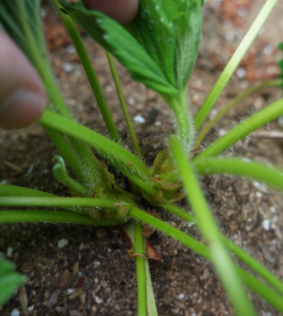
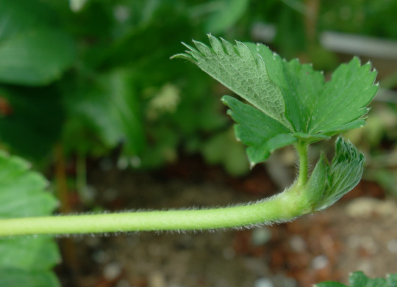

Inflorescence
  - Type: cyme
  - Flowers: Actinomorphic, complete; superior ovary, 3-5 per inflorescence. Petals bright pink in this cultivar; other cultivars are light pink to white.
  - How many petals: 5
  - How many sepals: Two whorls of 5, fused at bottom (tepals, connation) (note: one extra sepal seen in bottom whorl; this was not observed elsewhere).
  - How many stamens: ∞ (26 counted) in 3 whorls, adnated to the tepals
  - Carpels, how many? ∞

The cyme The flower, front and back
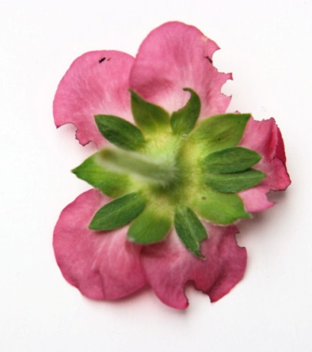
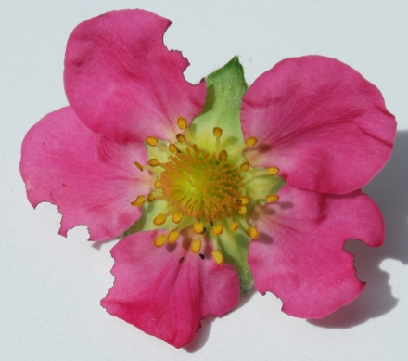
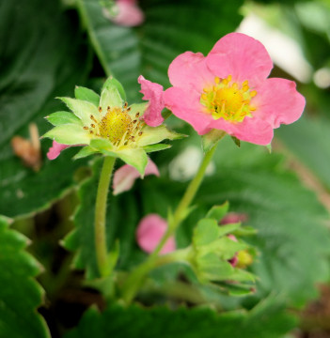

Gynoecium Androecium and Calyx (adnately fused)

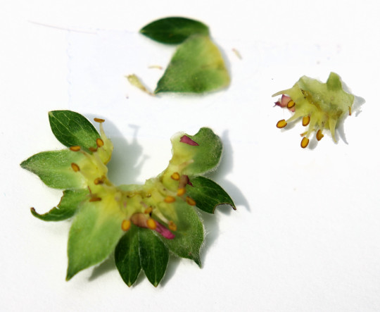
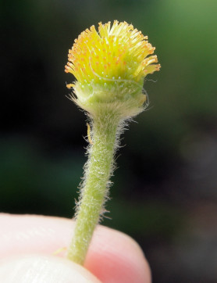

Seeds and Fruits
  - Type: Aggregate accessory, achenes born on a large, bright red, fleshy receptacle
  - Dehiscence? Indehiscent
  - Placentation? Uncertain (not apparent to this viewer)
  - Number of seeds? ∞, 1 per carpel

The achenes on the fleshy receptacle;
note the individual stigmas on the "seeds"
