Family: Boraginaceae
Specimen: Myosotis L. (prob. sylvatica), Forget-me-not
https://www.thinglink.com/scene/1340807922736693250

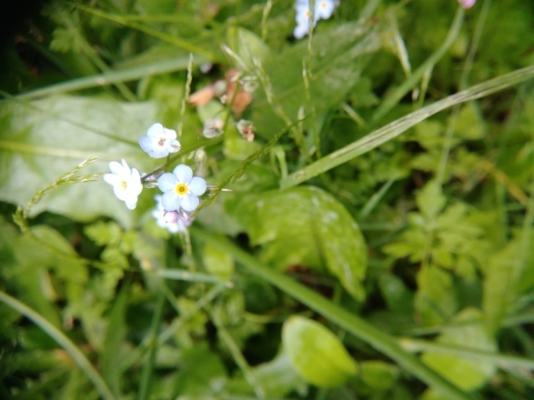

Habitat: Herbaceous, ruderal. Northern Hemisphere, temperate. Annual to biennial.

Vegetative Parts
  - Leaves simple, linear to lanceolate, alternate, entire; stamens, leaves, stem pubescent to hirsute. Basal leaves grow in a rosette. Taproot with diffuse rootlets.

Roots, stem and lvs. Hairs on stem and leaves can be observed.
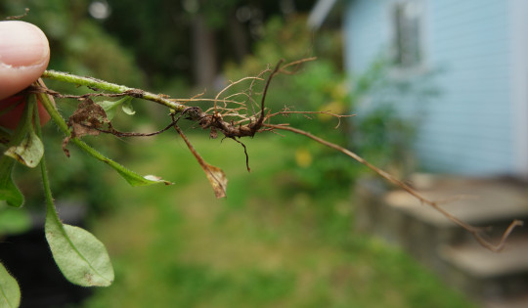

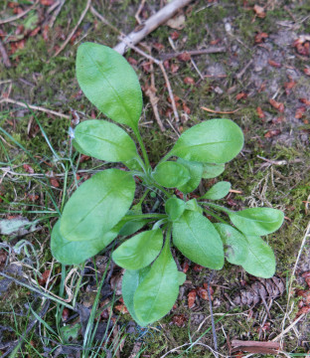
Rosette of leaves Hairy stem
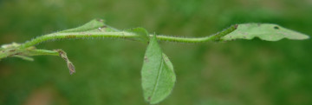

Front and back of leaves, which are fuzzy to touch
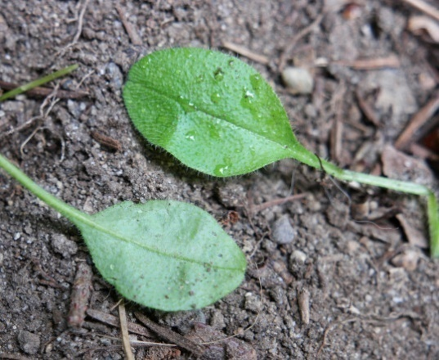

Inflorescence
  - Type: Scorpioid cyme, uncoiling as flowers bloom
  - Flowers: Actinomorphic, complete, blue, white or pink, with yellowish collar at throat; superior ovary.
  - How many petals: 5 flat petals connate at base into a lobed corolla.
  - How many sepals: 5 pubescent sepals slightly connate at base
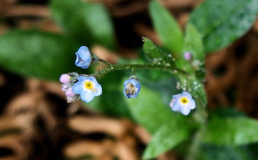
  - How many stamens: 5 adnate to corolla
  - Carpels, how many: 2 fused (connate)

Flower - scorpioid cyme, almost unfurled

Corolla front; note yellow throat Flower back - pubescent calyx/sepals
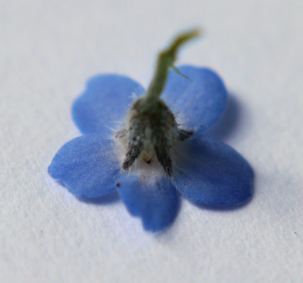
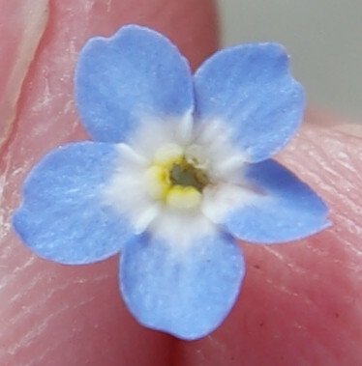

Androecium; corolla and adnated stamens enhanced in right frame for better visibility
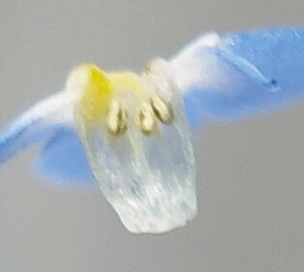
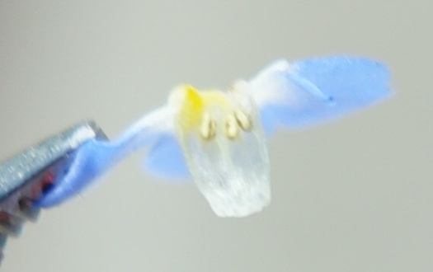

Gynoecium - see photos in Fruits

Seeds and Fruits
  - Type: schizocarp that breaks into 4 mericarps*often called "nutlets"
  - Dehiscence: Indehiscent
  - Placentation: basal, maybe axial as well*
  - Number of seeds: 4

* src: https://www.delta-intkey.com/angio/www/boragina.htm

Nutlets forming at base of sepals; 2 of 4 nutlets forming around the style. Difficult to interpret placentation; operator error with camera and lens autofocus malfunction impacting qualify of photo.

