PLANT BINGO
needle connation actinomorphic
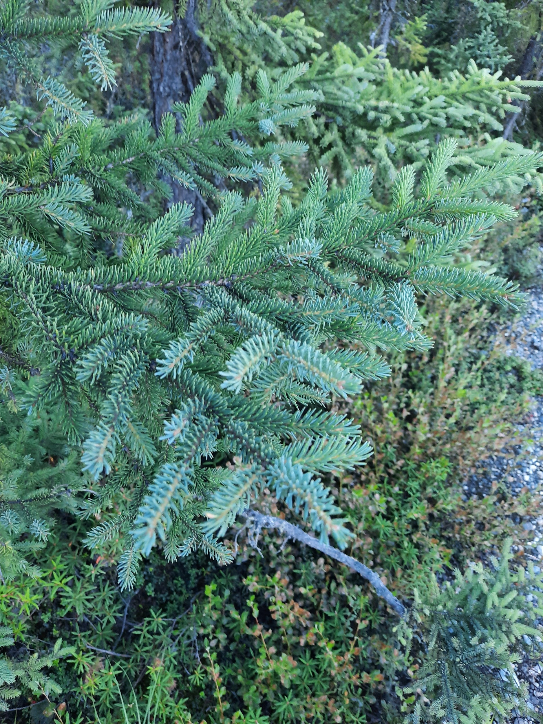
Diadelphous silique inferior ovary
palmate venation adnation porate anther dehischence

