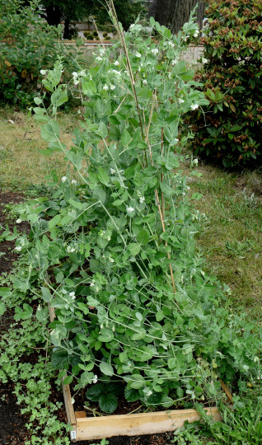
Family: Fabaceae, subfamily Faboideae
Specimen: Pisum sativum L., garden pea
https://www.thinglink.com/scene/1340818370567602178

Habitat: Herbaceous cultivar. Annual. Popular food crop.

Vegetative Parts
  - Leaves (inc. close-up of front and back, stipules), roots, stems: Roots fibrous. Leaves blueish-green, waxy, alternate, stipulate, pinnately compound; leaflets opposite and entire; enlarged stipules at base of petiole slightly sheathing, dentate at the base. Tendrils present.

A) Roots, B) compound leaflets, stipules and tendrils , C) front and back of leaflets, D) stipules and tendrils, E) close-up of stipules; dentate margin at base can be observed.

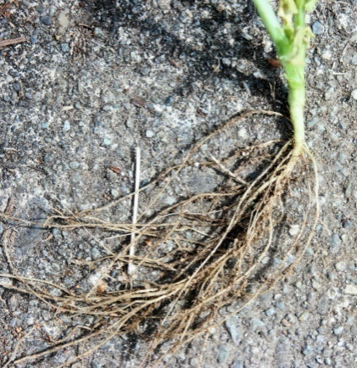
A. B.
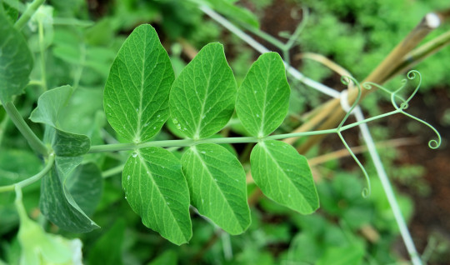

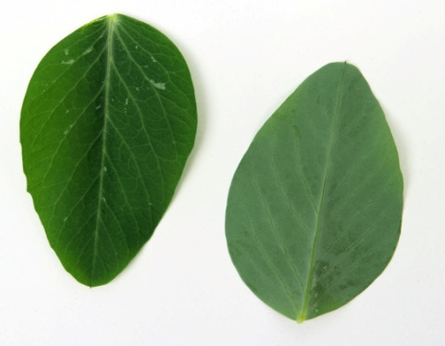
C. D. E.
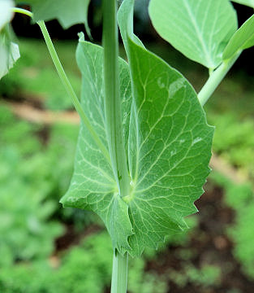
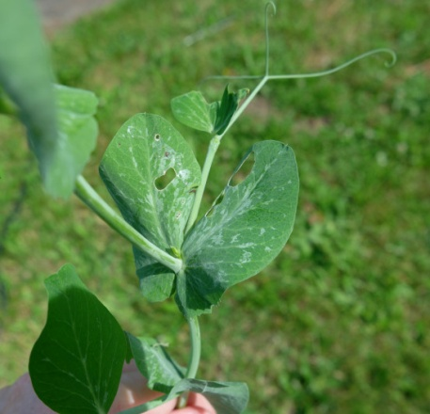

Inflorescence
  - Flowers: White, complete, alternating, zygomorphic.
  - How many petals: 5 - a keel (two petals fused together, enclosing the androecium and gynoecium), two wings which surround the keel, and a banner (one petal) which envelopes the other petals.
  - How many sepals: 5, connate at base; green.
  - How many stamens: Diadelphous 9+1; the 9 are connate and (almost) closed into a tube, and the 10th is free
  - Carpels, how many: 1

Petals: Keel (bottom), Wings (flanking) and Banner (top)

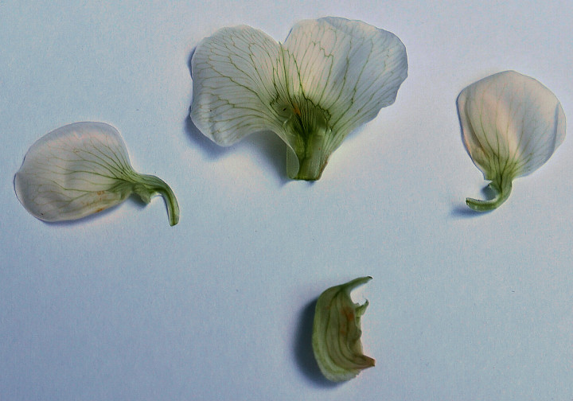

Calyx: Dissected; in situ on back of flower

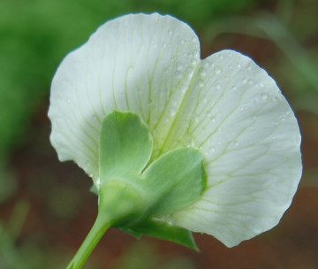
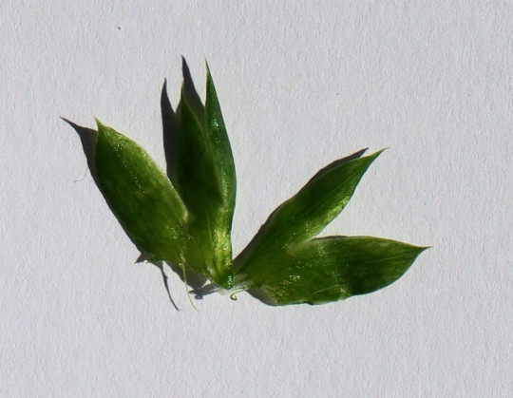

Androeceum and gynoecium; the diadelphous stamens and feathery stigma are clearly visible

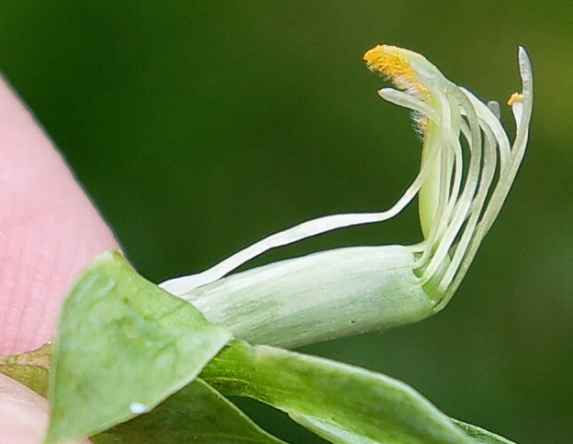

Gynoecium

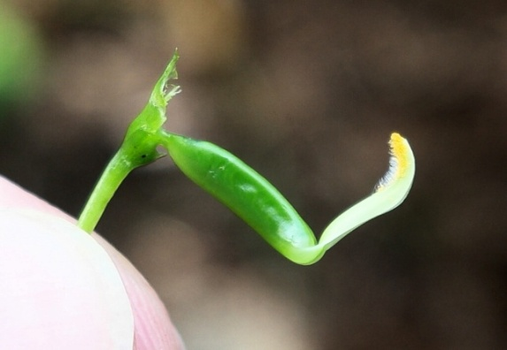

Androecium - 9+1 arrangement clearly visible (most anthers lost in handling)

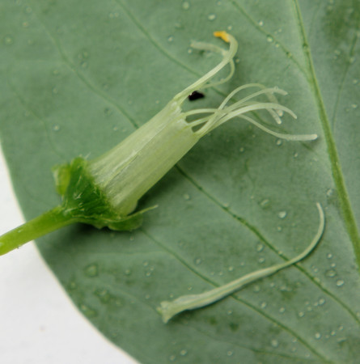

Seeds and Fruits
  - Type: Legume. Fruits mature within a pod, which opens on both seams when mature; remnants of calyx on stipe and withered style observed.
  - Dehiscence: Dry dehiscent
  - Placentation: Basal
  - Number of seeds: 6 observed in this dissection.

Pea pod. Note remnant of style at terminal end of pod (top). Remnant of calyx seen attached to stipe (bottom).

