Family: Ranunculaceae
Specimen: Ranunculus repens L., creeping buttercup
https://www.thinglink.com/scene/1340556739832971265

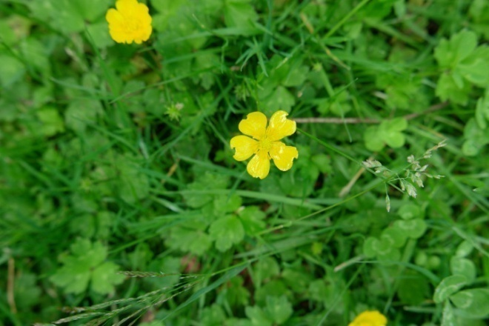

Habitat: Herbaceous, ruderal, often found on wet-land margins. Perennial.

Vegetative Parts
  - Leaves basal, alternate, compound palmately into three leaflets, palmate venation, deeply lobed with "dentate" toothing; end leaflet up to 4cm wide. Dark green on top, light green underneath. Leaves and stems pubescent. Roots adventitious off stolons, fibrous. Lacks stipules (presence or absence of stipule is diagnostic for clarification Ranunculus and members of Rosaceae).

Front Back
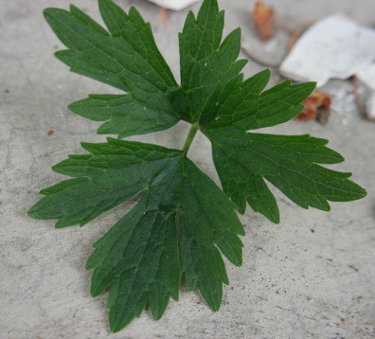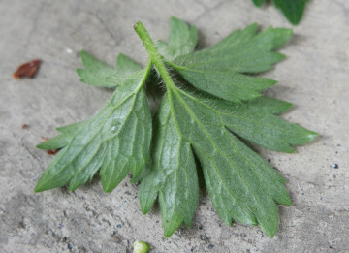

Notice pubescent stems and petioles, and adventitious roots forming at node; stolons and roots

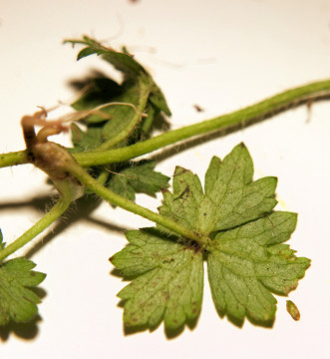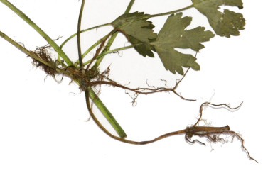
Inflorescence
  - Type: Single showy flower borne on stem
  - Flowers: Actinomorphic, complete. Petals bright yellow, very glossy, sepals green. Superior ovary. Erect flowers on stems.
  - How many petals: 5
  - How many sepals: 4
  - How many stamens: ∞ (many)
  - Carpels, how many: ∞ (many)

Flower; notice glossy appearance of petals Petals and sepals
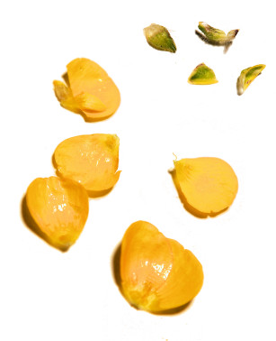
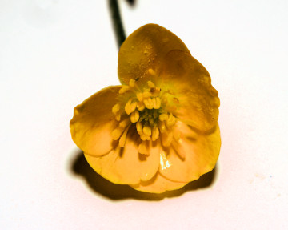

Gynoecium

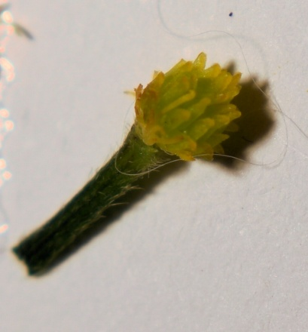

Androecium: stamens and filament; close-up

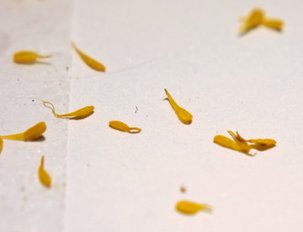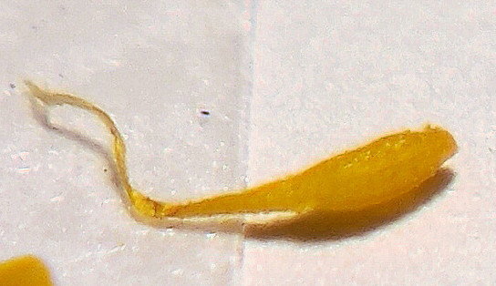

Seeds and Fruits
  - Type: Aggregation of achenes in clusters
  - Dehiscence: Indehiscent
  - Placentation: Basal*, difficult to observe
  - Number of seeds: 1 per carpel
*src: https://www.nrcresearchpress.com/doi/pdfplus/10.4141/cjps90-135

Seeds Dissected seeds; placentation appears to be basal

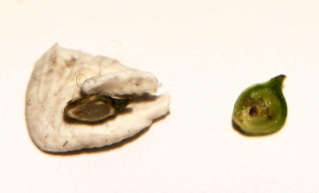
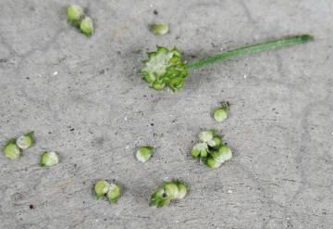

Note spurs on seeds
