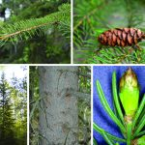
Plant 1 | Green needles
 | Skinny pinecone
 | Stem Not hairy - glabrous
 | woody

- 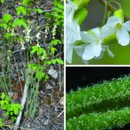
Plant 2 | Flower
 | White petals
 | Hairy stem - strigose

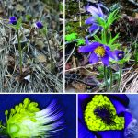
Plant 3 | Flower
 | Purple petals
 | Hairy stem - strigose

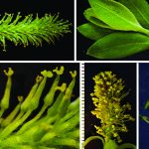
Plant 4 | Many small Flowers
 | Petals yellow
 | Hairy stem - strigose

Dichotomous Key

- Plant with needles
B. Pinecone present – plant #1
(A’). Plant without needles
C. Plant with teeny tiny flowers, packed closely together
D. Flower color: yellow – plant #4
(C’). Plant with flowers, not packed closely
E. Petal color purple – plant #3
(E’). Petal color white – plant #2

