Fireweed: great willow her, wickup, perennial wildflower

Family: Onagraceae

Inflorescence: tall showy pink or purple long clusters

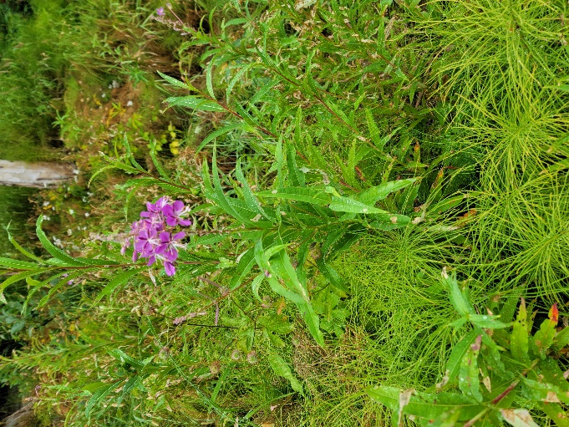

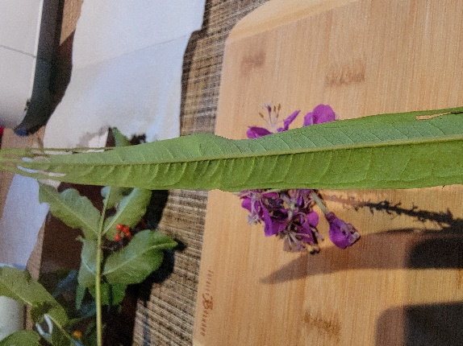

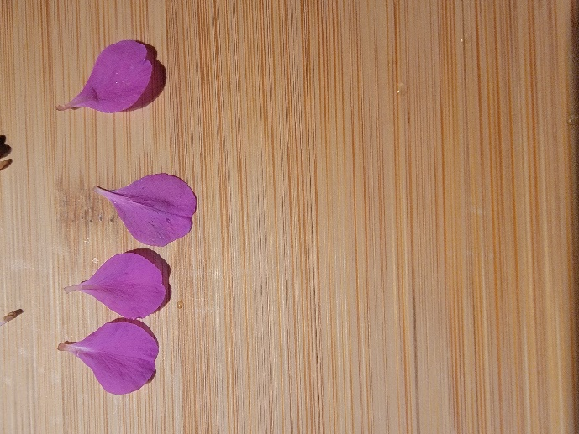

Stigam: 1

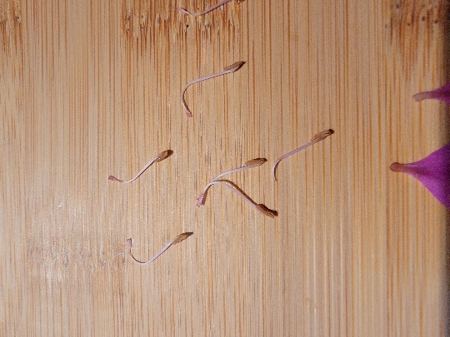

Stamens:8

Petals: 4



Dehiscence: Longitudinal

Sepals: 4

Rose: Prickly Wild Rose

Family: Rosaceae

Inflorescence: Rosy-pink with yellow central flowers

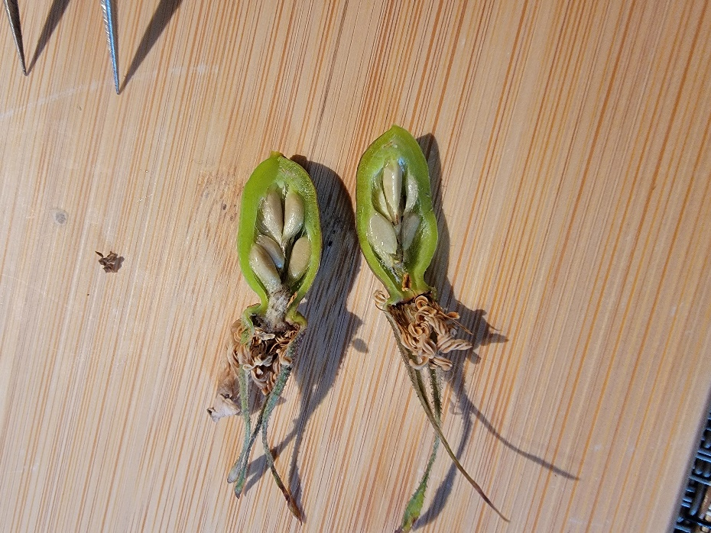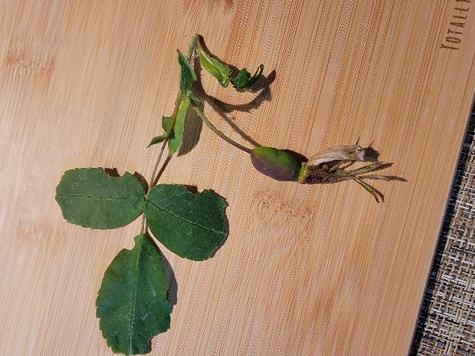

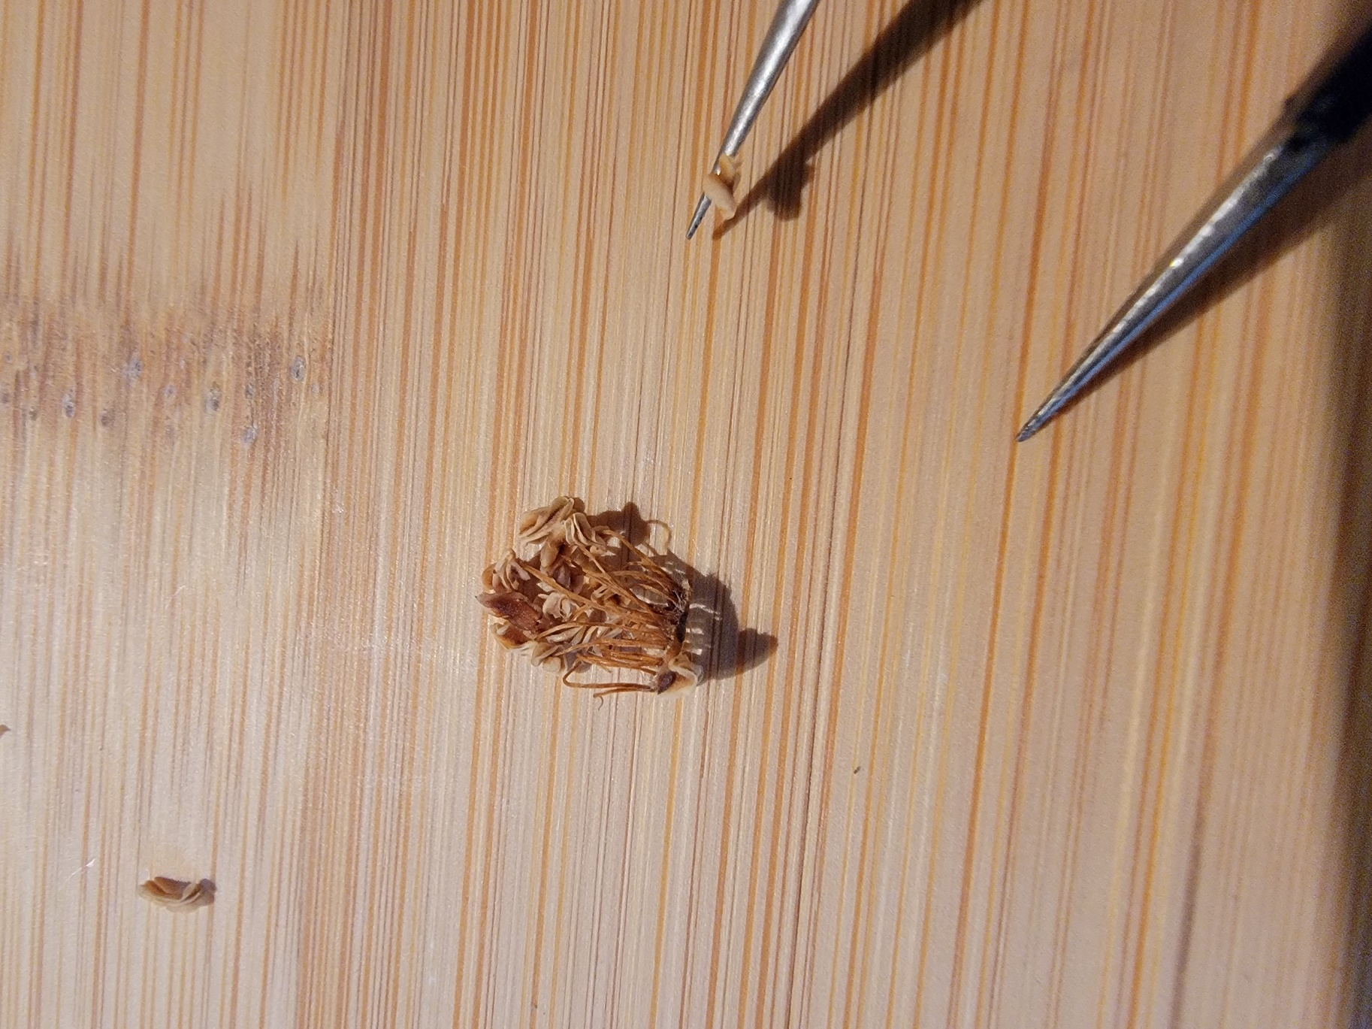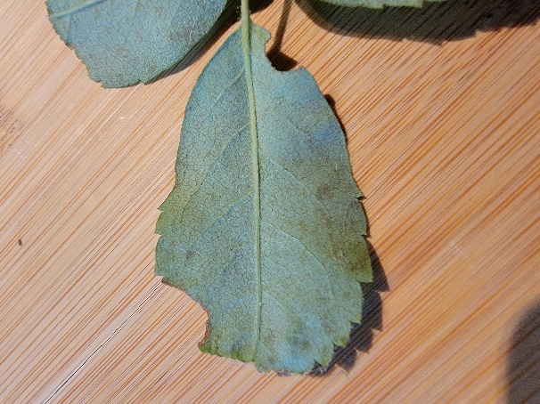

Petals:5 adnation

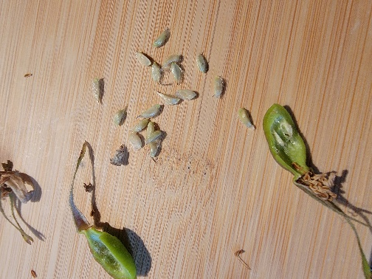

Seeds: 18

Watermelon Berry: Twisted Stalk, wildberry, reddish, white, or yellow sweet juicy flesh

Family: Liliaceae

Inflorescence: alternate, oblong-lanceolate

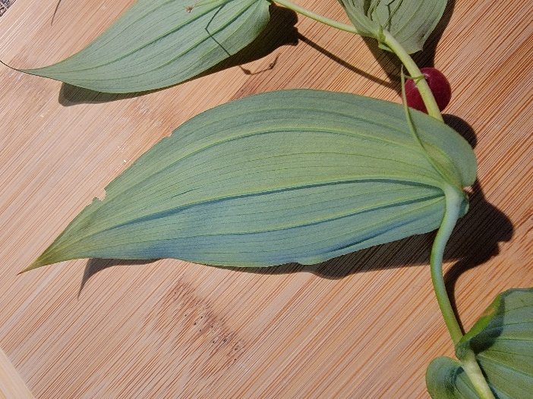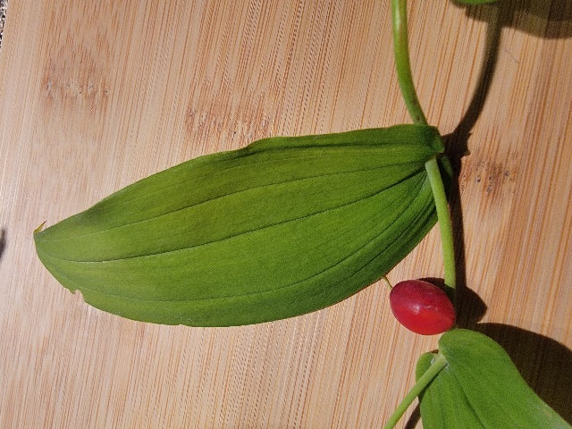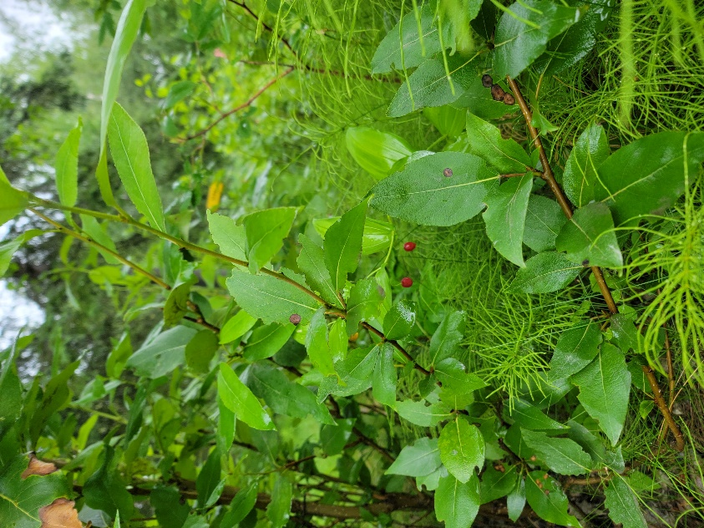

Seeds: 14

Red Elderberry: Sambucus racemosa

Family: Caprifoliaceae

Inflorescence: showy shrub, red berry clusters

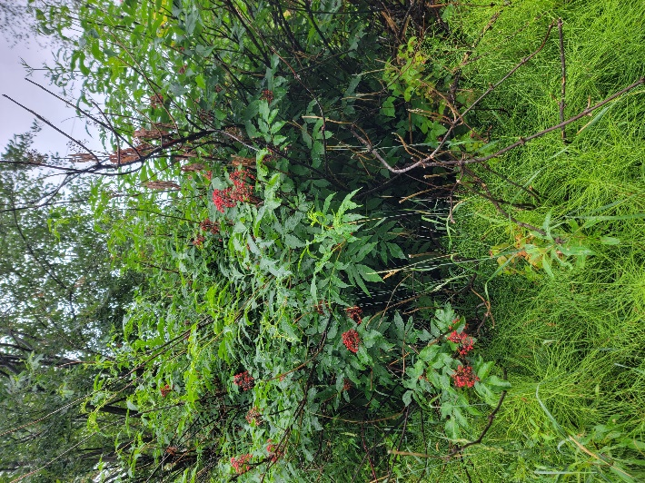

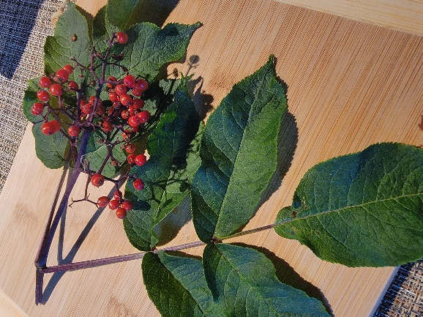

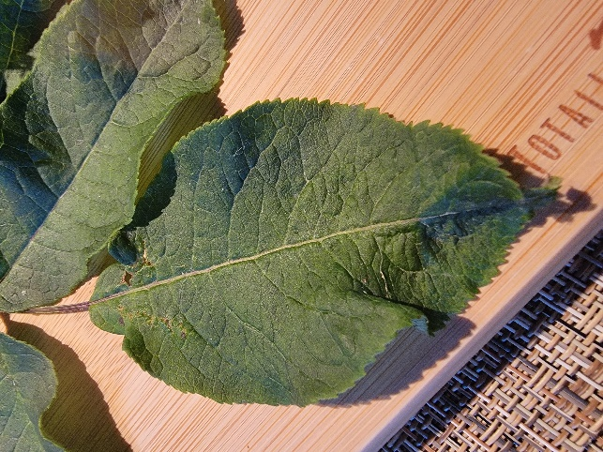

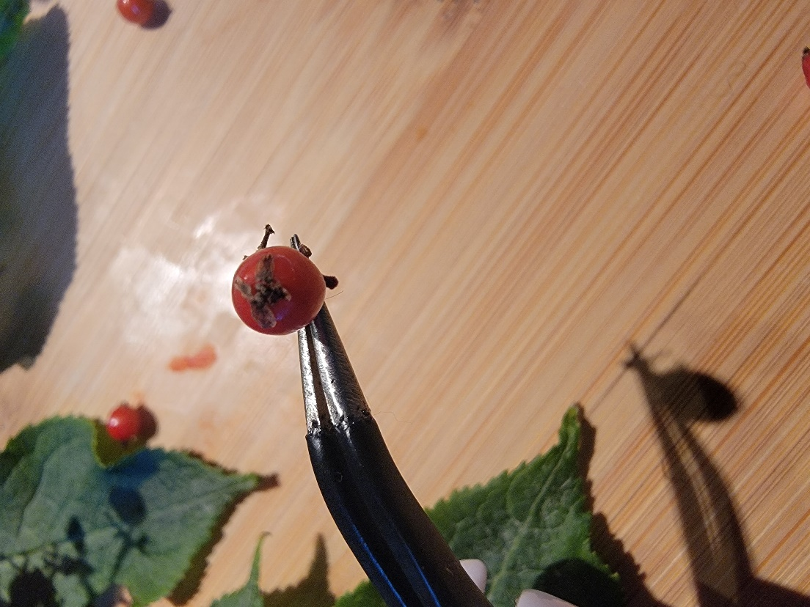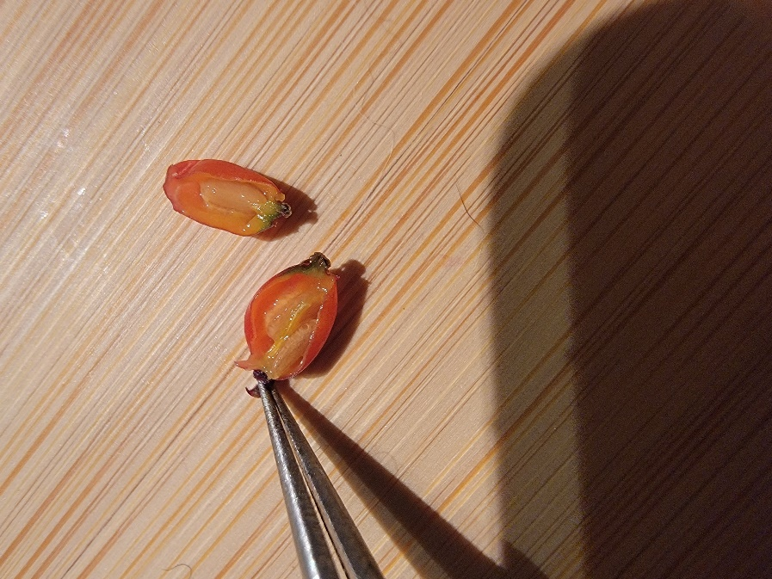

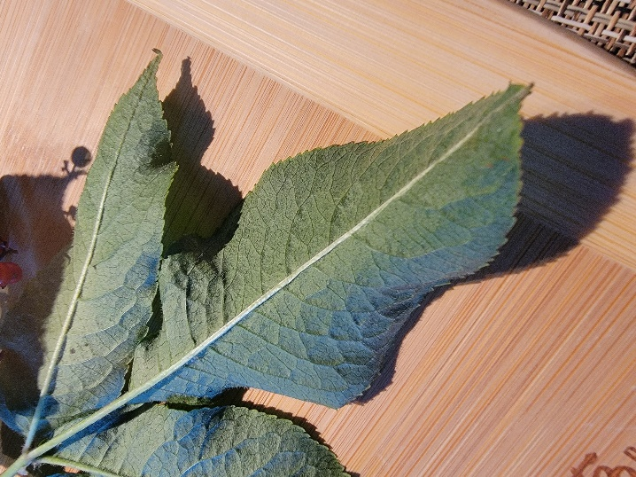

porate anther dehiscence

Seeds: 4