Ericaceae – Rhododendron menziesii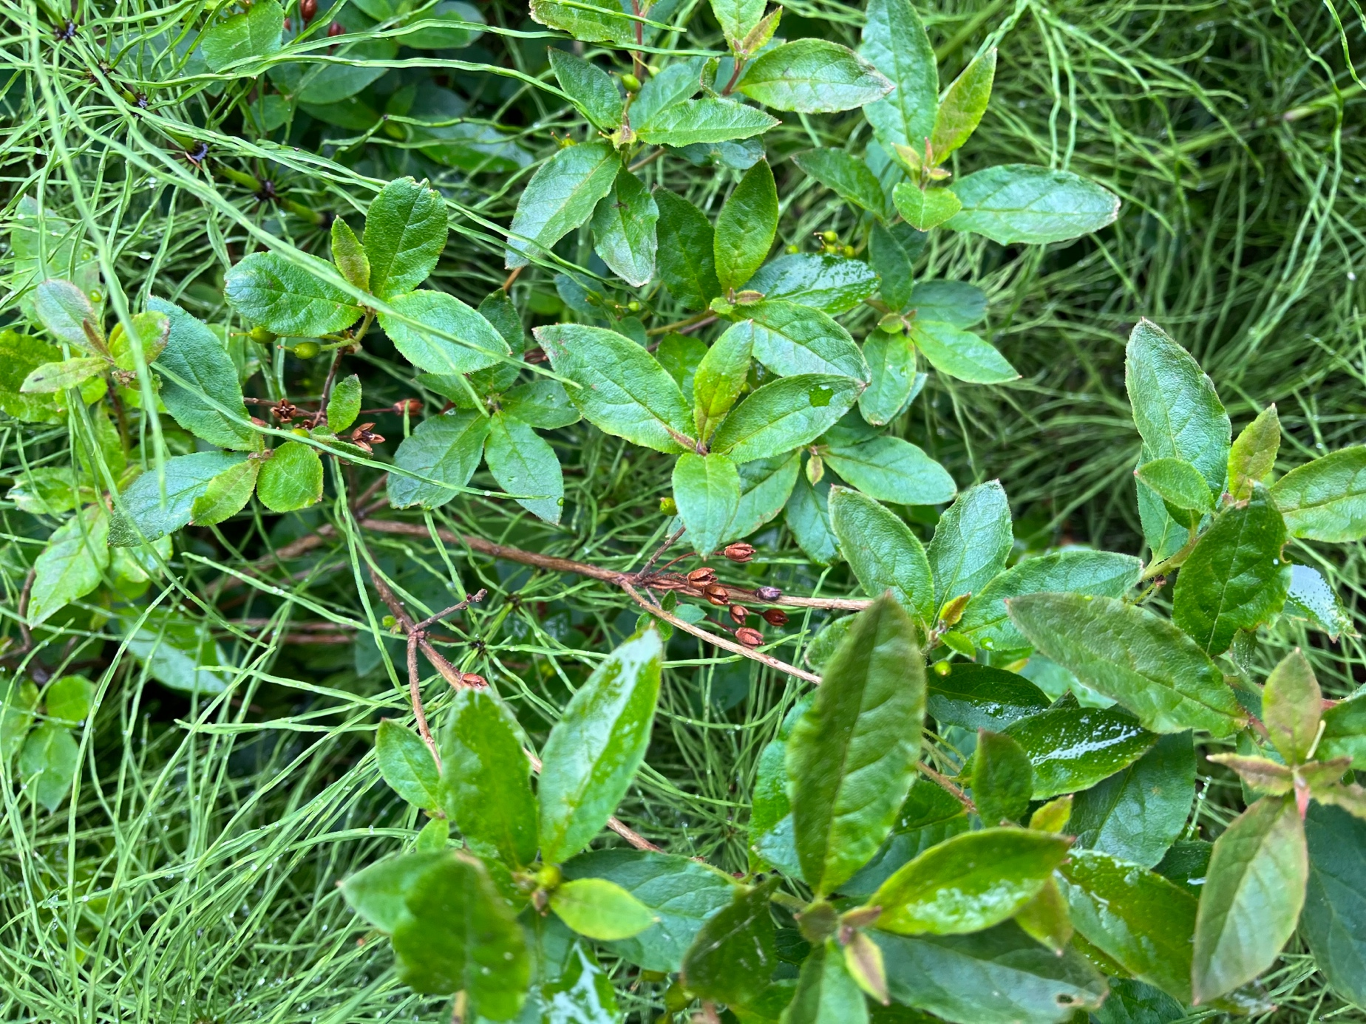

Figure 1: Habitat edge of coastal spruce forest in Homer, Alaska, growing with horsetail

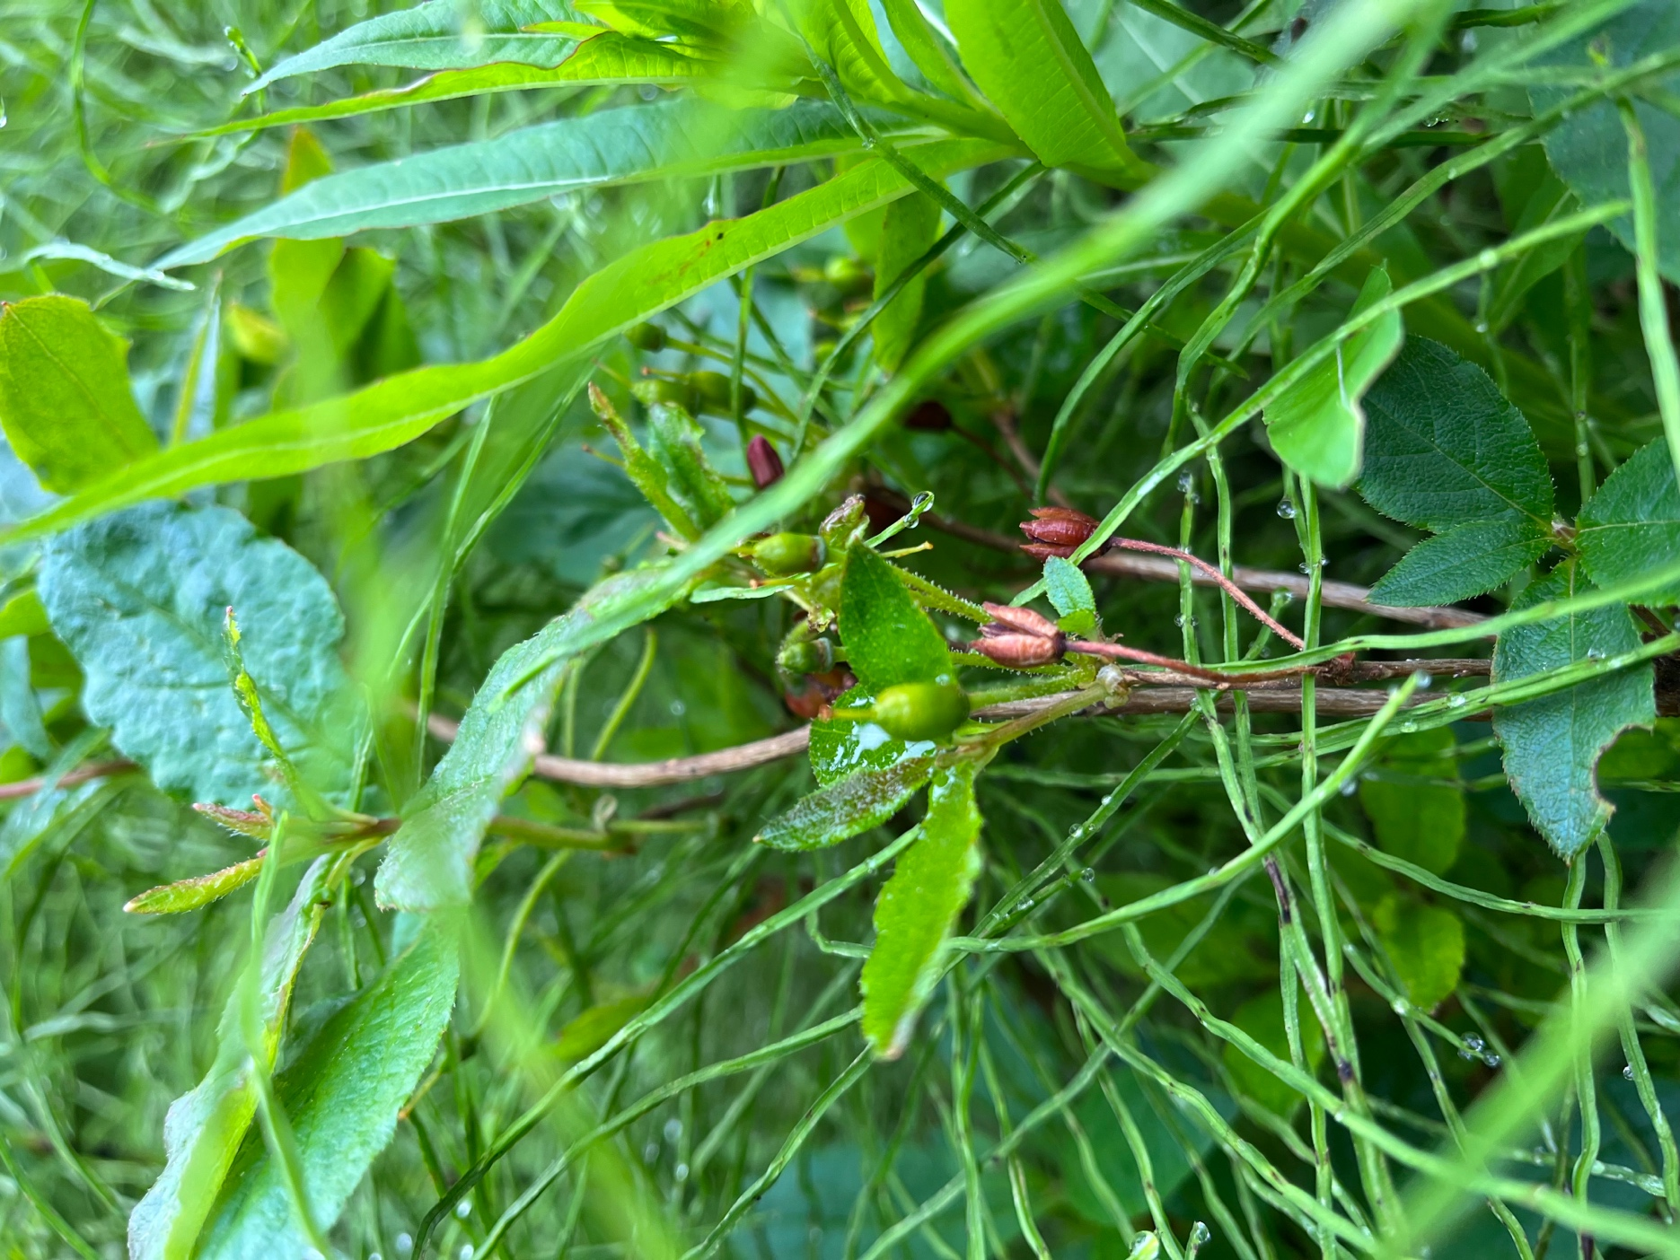

Figure 2: fruits mature as capsules, alternate leaves are elliptic to obovate and margins are entire

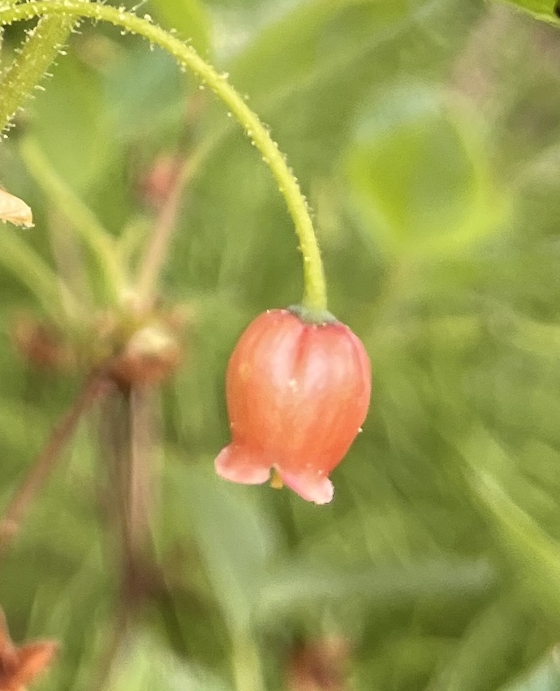

Figure 3: 4 Terminal flowers are clustered, adnate pinkish orange corollas hang in a bell shape

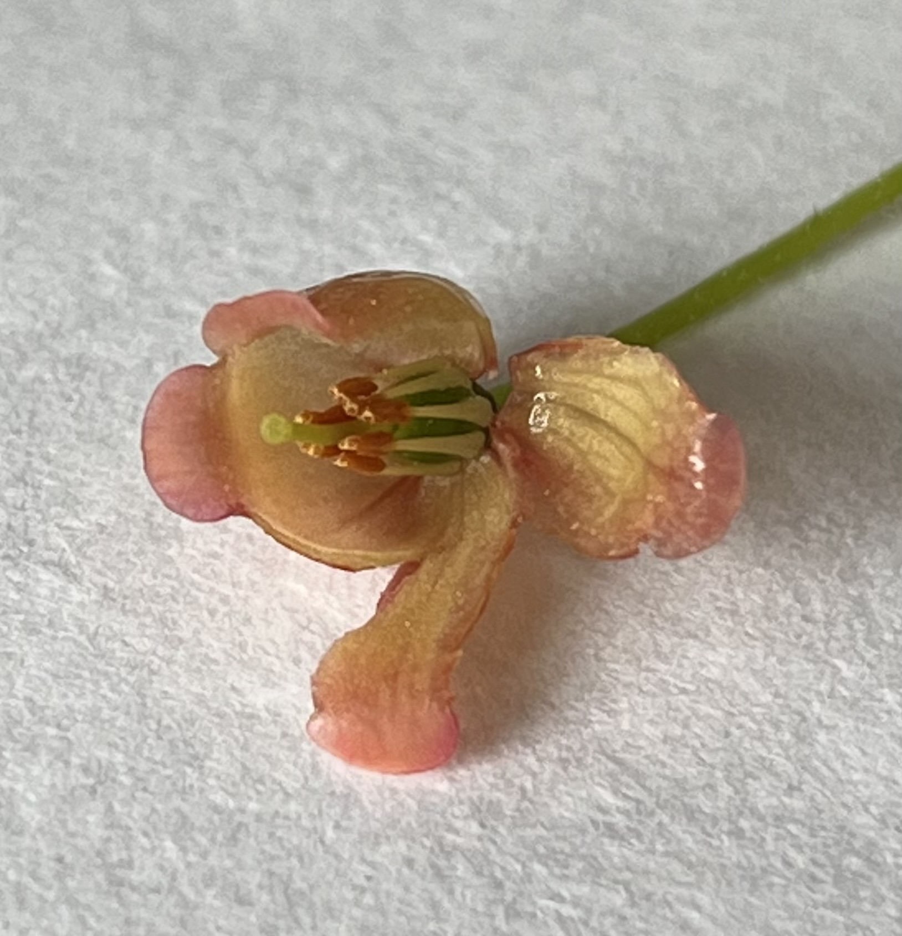

Figure : 8 anthers with poricidal dehiscence, superior ovary