Cornus canadensis

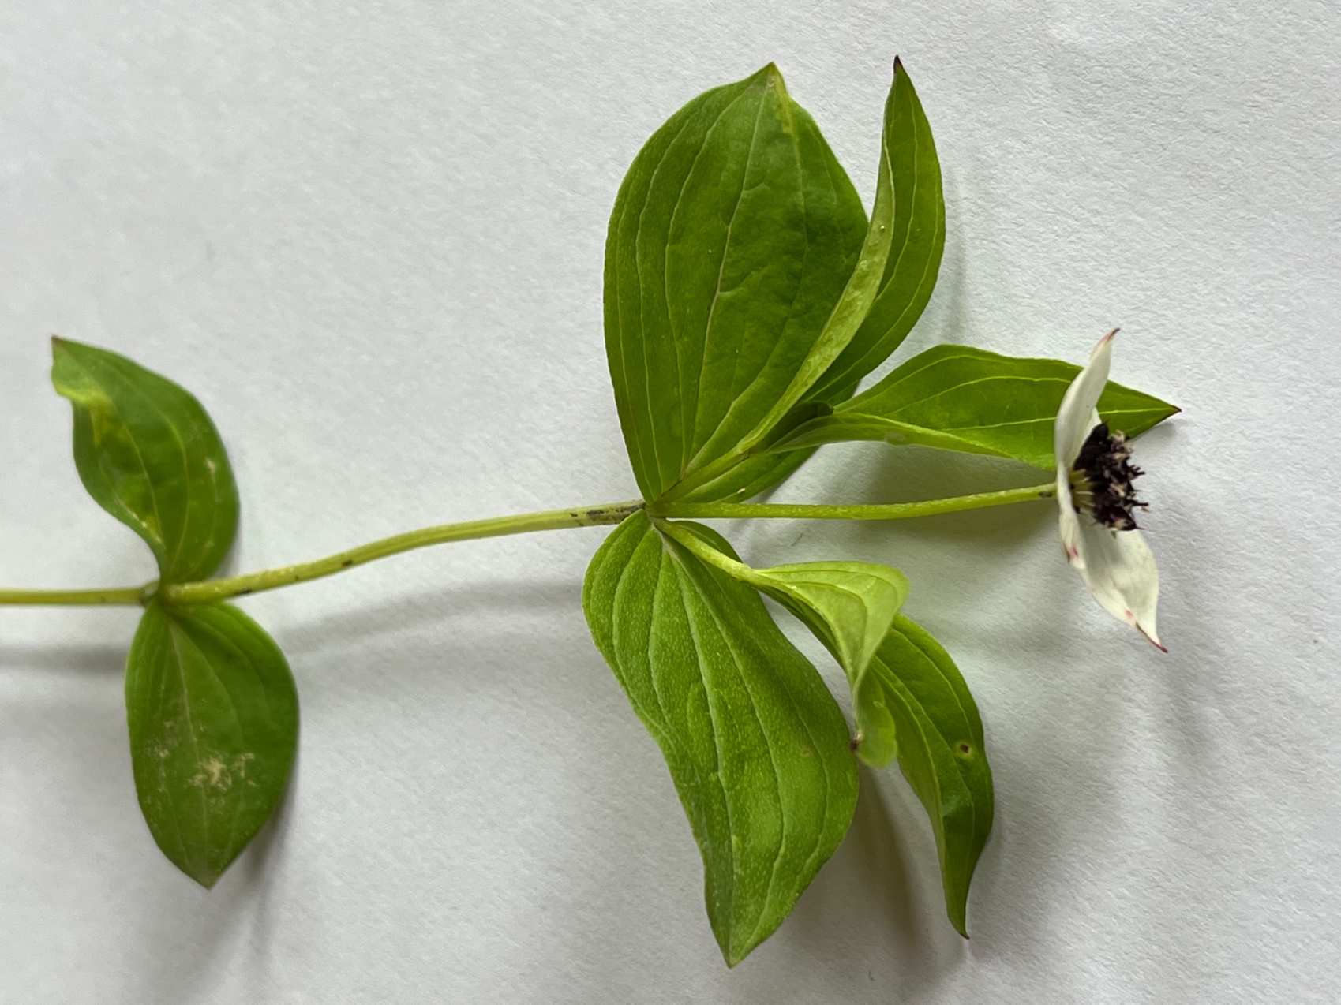

Figure 1: Opposite leaves have arcuate venation

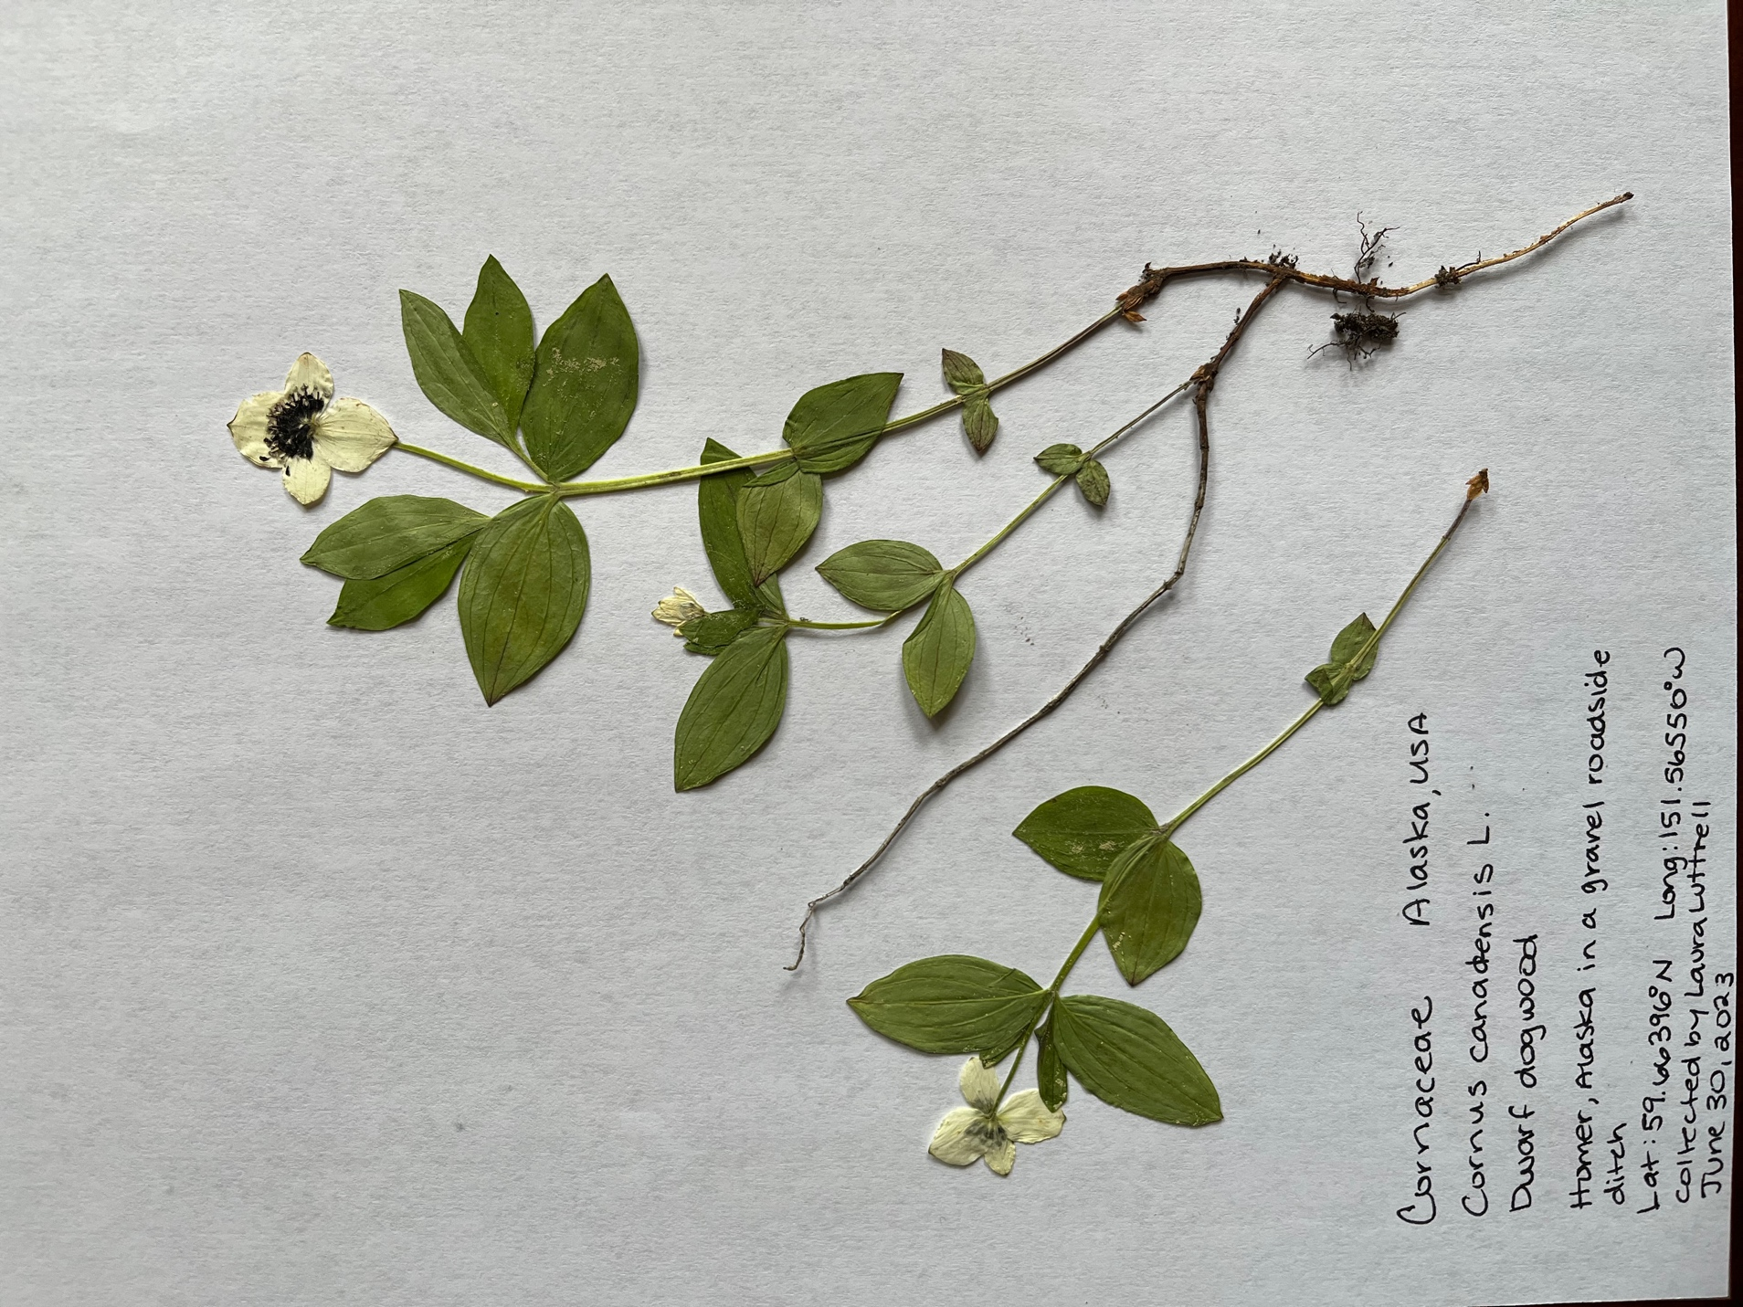

Figure 2: 4 white petal-like bracts surrounding a cluster of 2 mm flowers, Each flower has 4 stamens, 4 adnate petals and sepals, and an inferior ovary (I was able to see this with a hand lens, but not photograph it)