*Orchidaceae*

*Platanthea* spp.

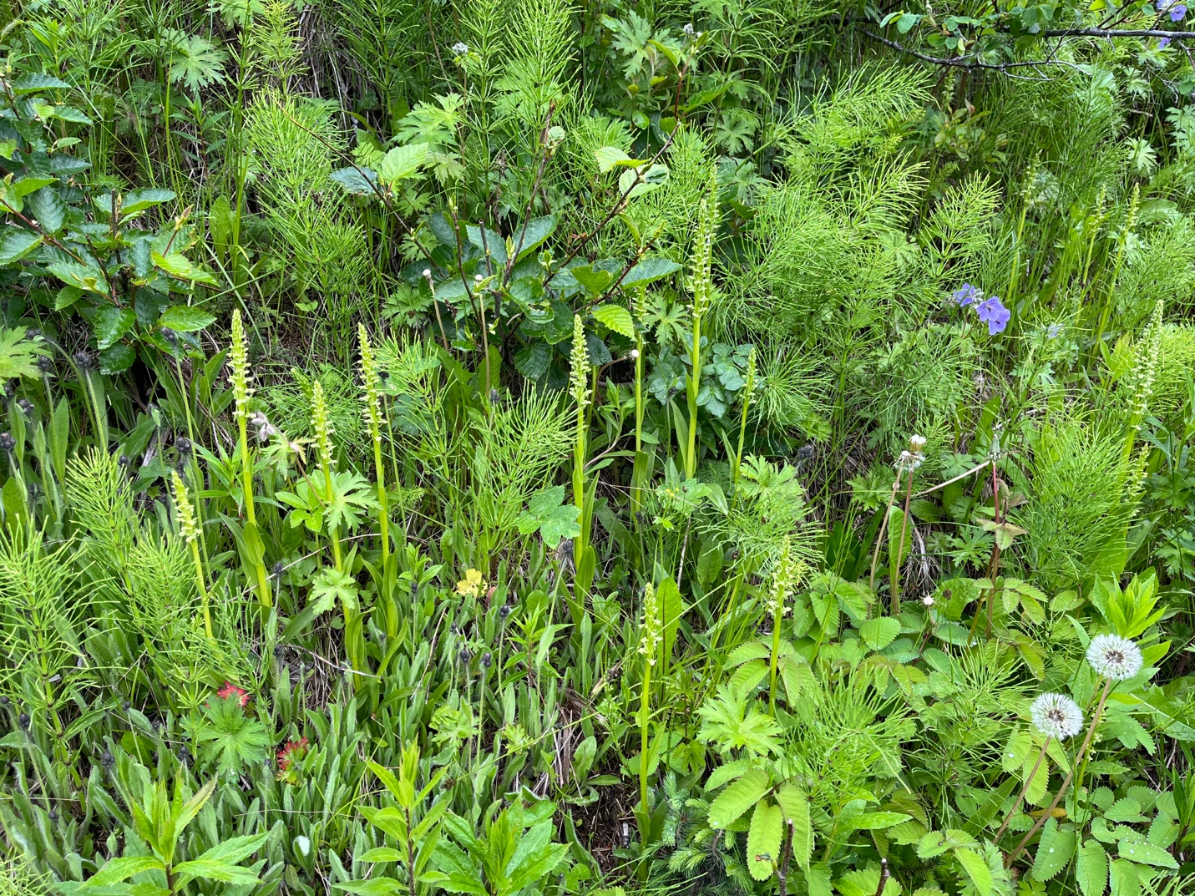

Figure : Habitat roadside ditch in Homer, AK, growing with other perennial herbaceous wildflowers and plants

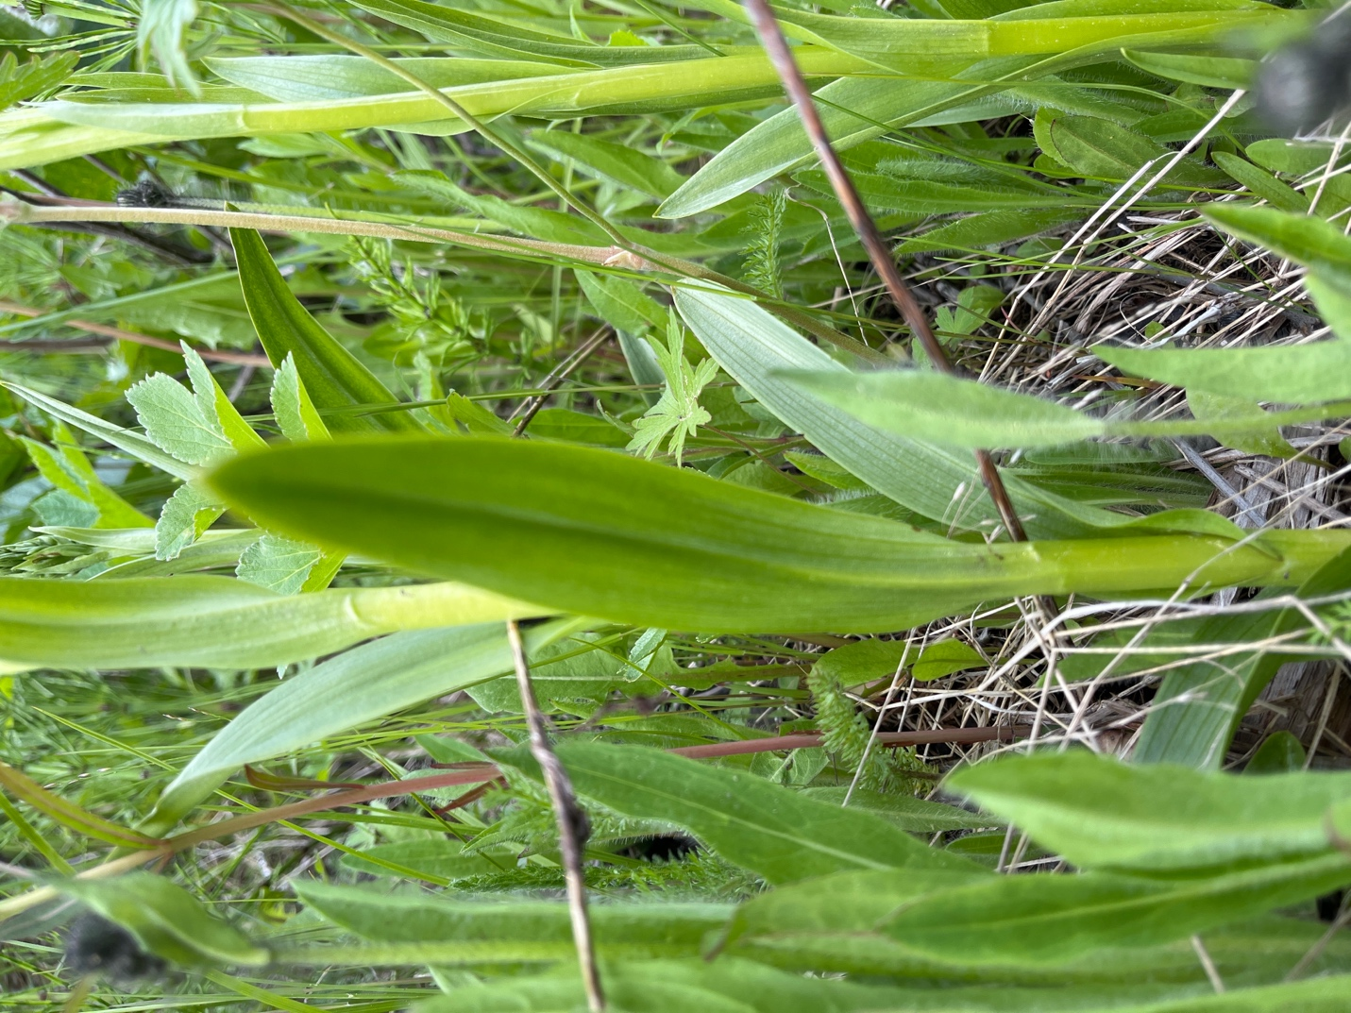

Figure : Leaves are lanceolate and 3-7 cm alternating along stem, base of leaves sheath the stem

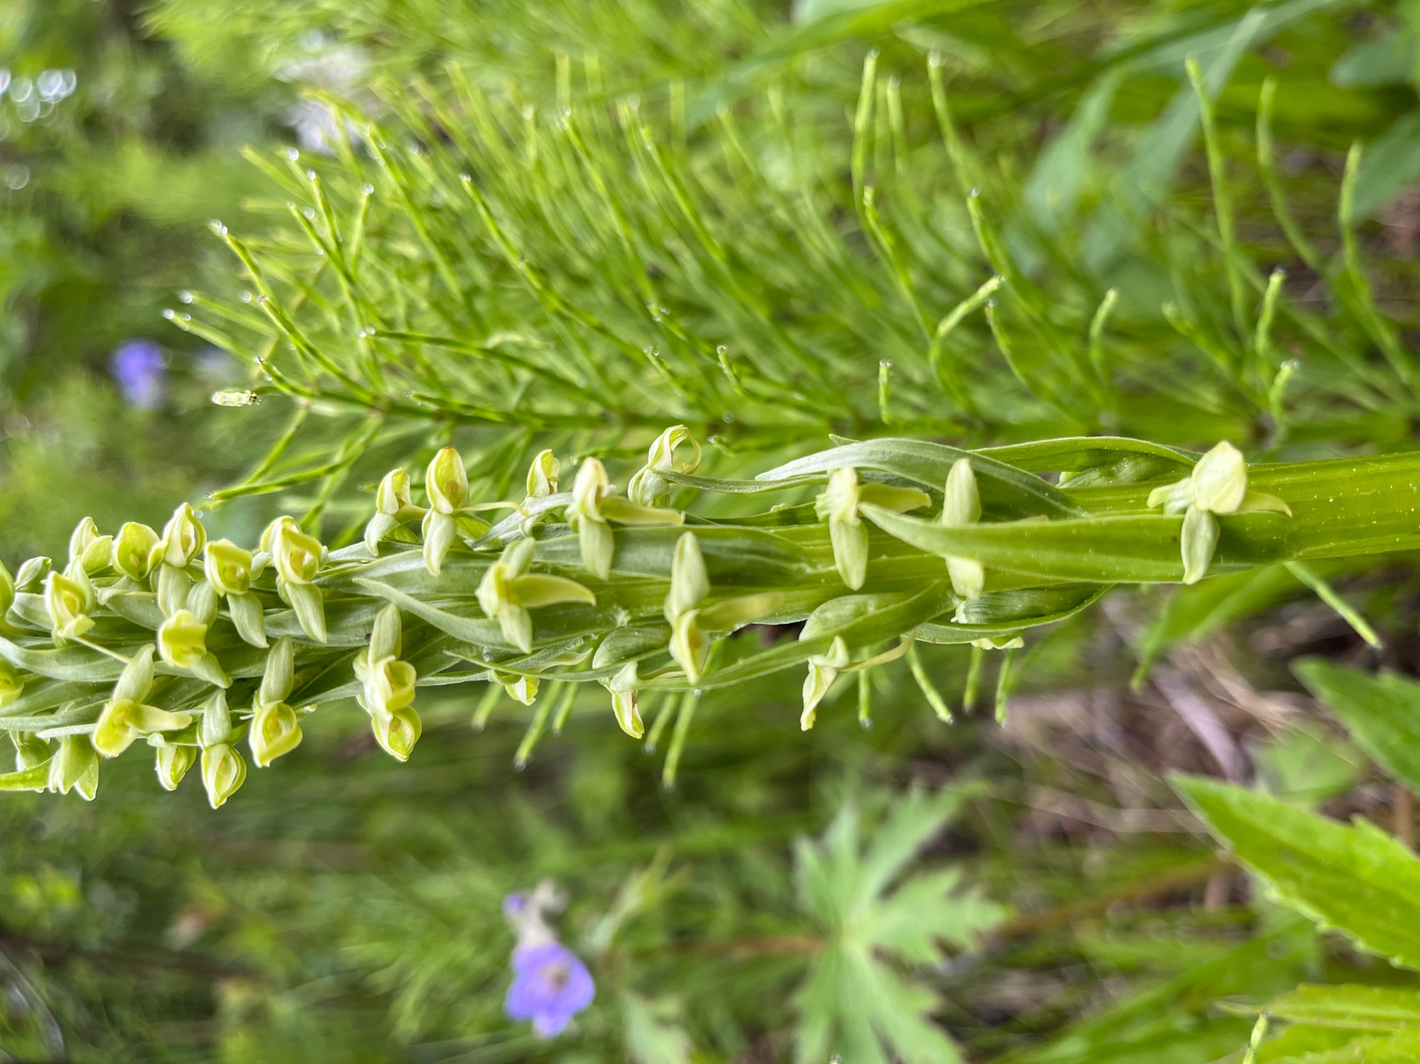

Figure : Solitary inflorescence with densely populated whitish green flowers

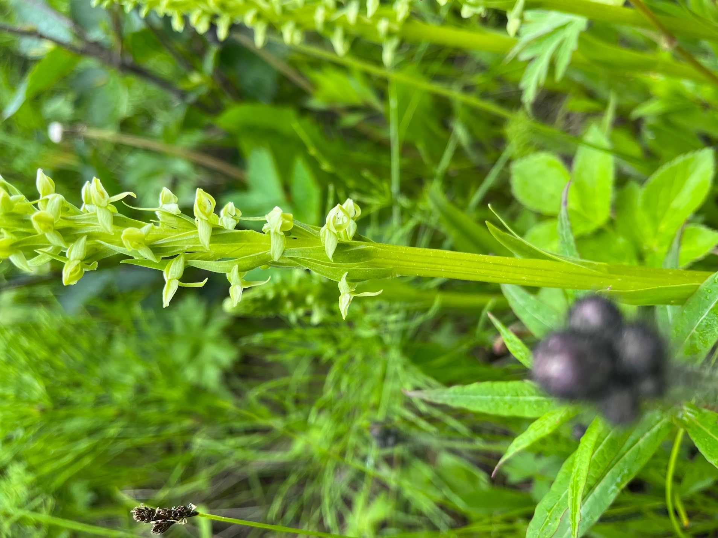

Figure : each flower has a lanceolate floral bract that sheaths the stem, approximately 5-25 mm long

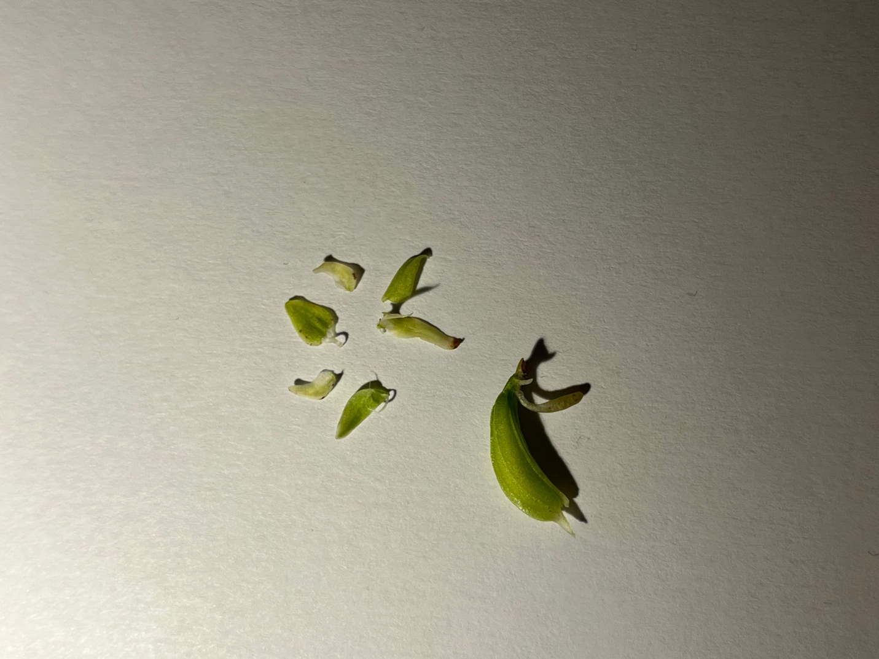

Figure : 3 sepals and 3 petals with edges entire 3-5 mm except simple labellum which is elongated 6-7 mm, nectar spur present

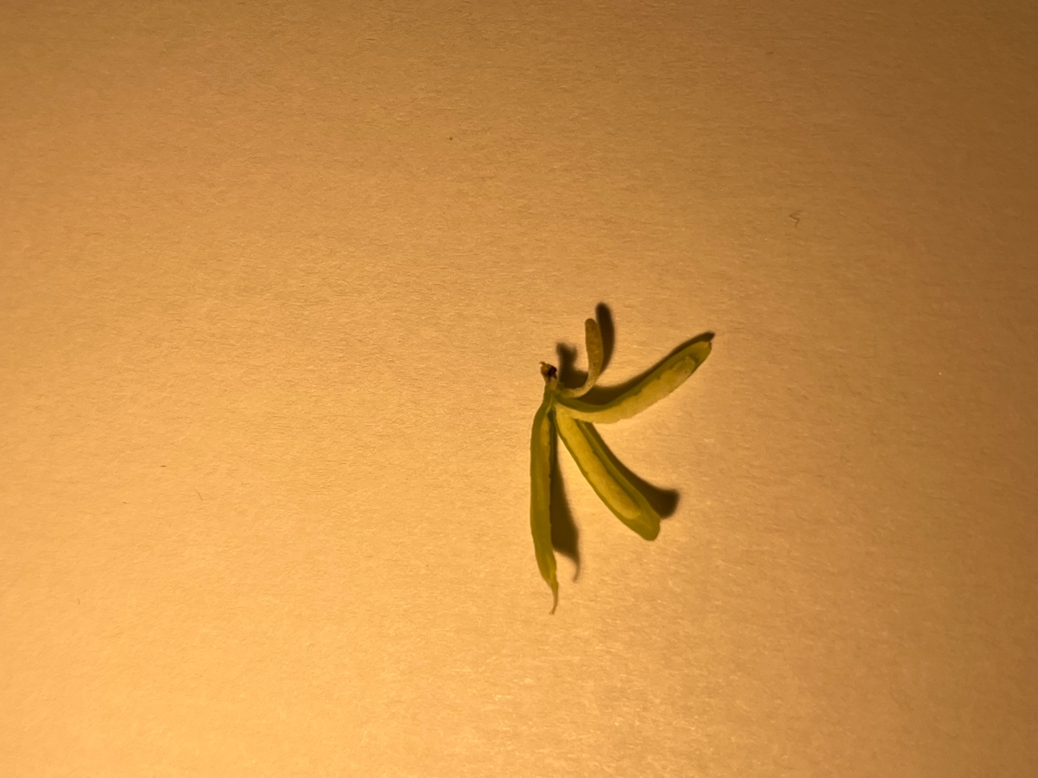

Figure : Nectar spur parallel to Inferior ovary with 3 locules