Fabaceae.

*Lathyrus* *japonicus – beach pea*

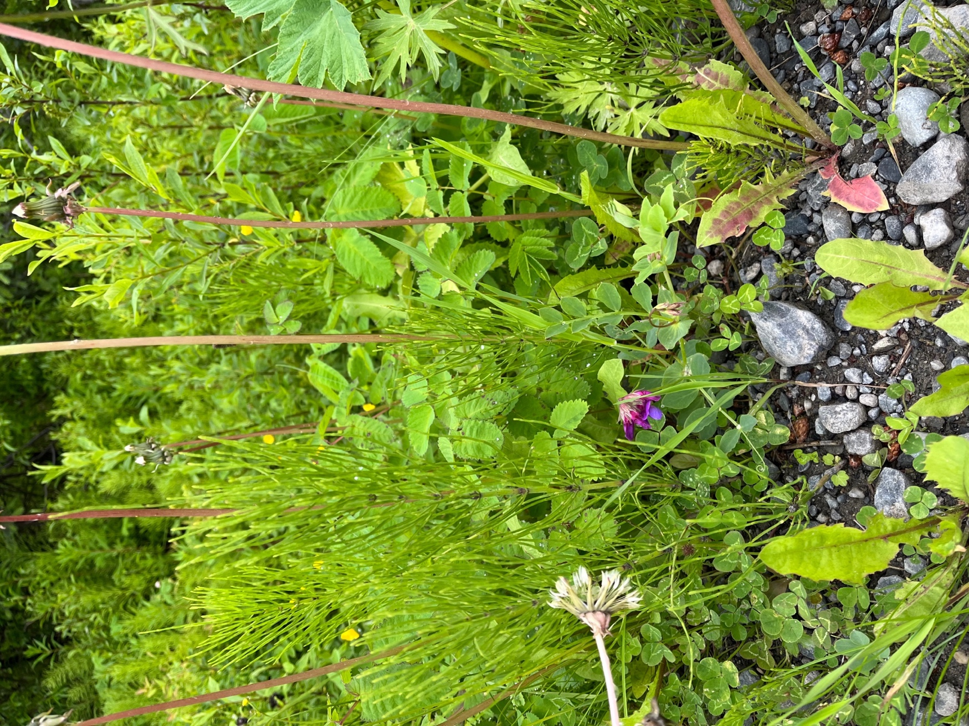

Figure 1: Habitat gravel roadside ditch with other perennial herbaceous plants in Homer, Alaska

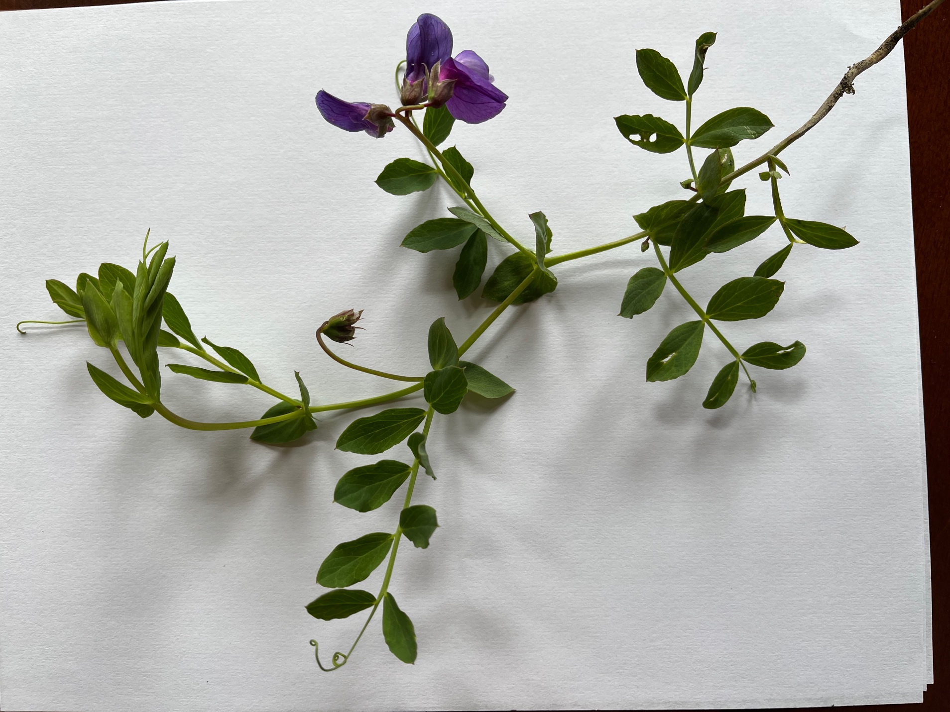

Figure 2: Indeterminate stem with axillary leaves and axillary inflorescence, terminal tendrils, leaves are stipulate, leaflets are even-pinnate

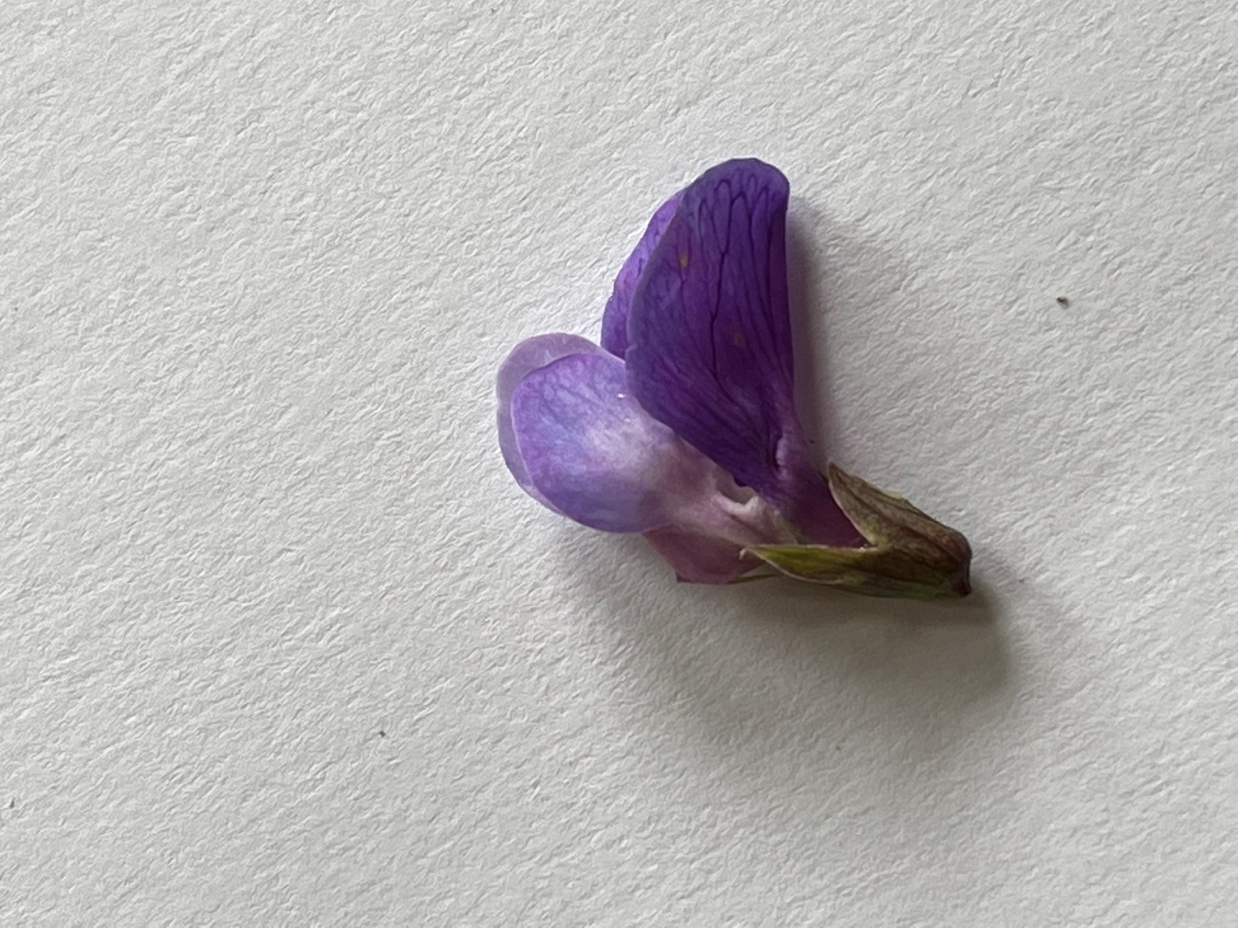

Figure 3: connate sepals, 5 petals: banner is dark purple and made of 2 adnate petals, wing and keel are lighter purple petals

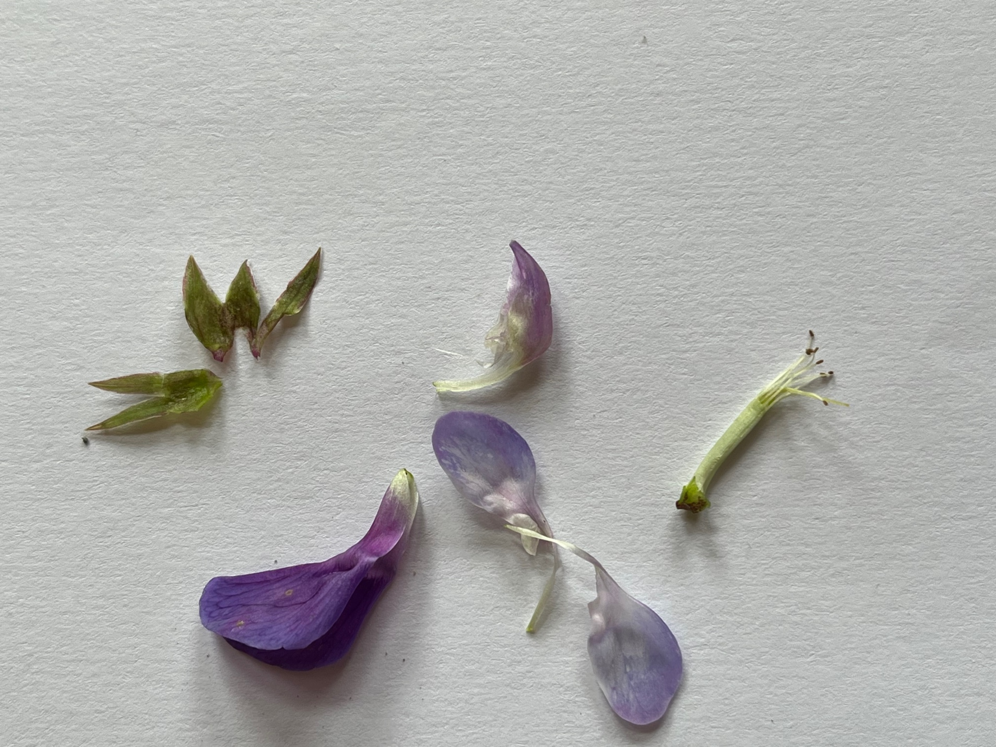

Figure 4: 5 connate sepals, 5 petals, 10 partially connate stamens

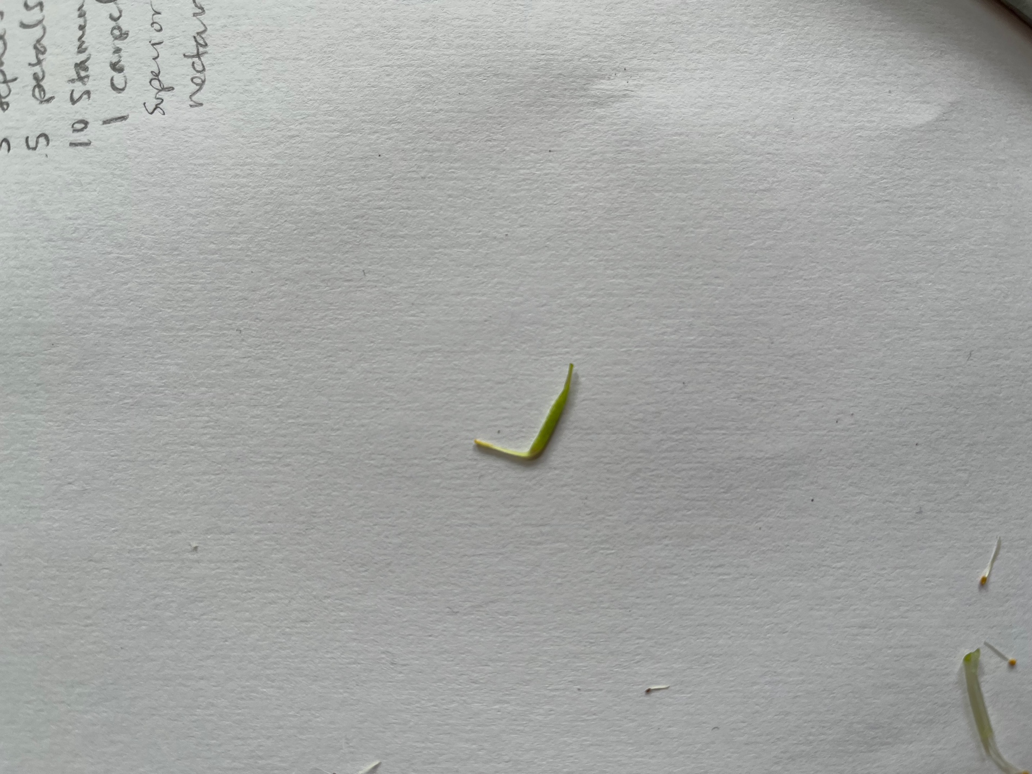

Figure 5: 1 carpel, superior ovary