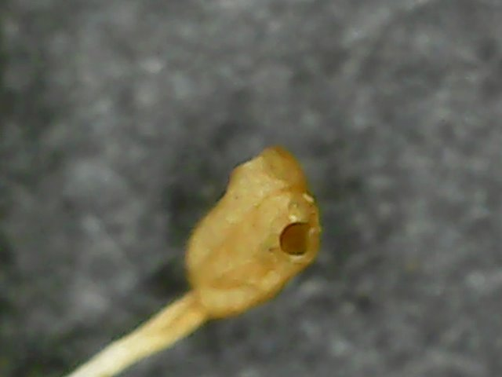

Figure 1. Poricidal anther dehiscence example. Labrador Tea.

Figure 2. Septicidal capsule example. Labrador Tea. (Upper = Horizontal cross section of Labrador Tea fruit). See article “**Rhododendron groenlandicum** (Oeder) Kron & Judd” found at this link: <https://newfoundland-labradorflora.ca/flora/dview/?id=485>

Figure 3. Axile Placentation example. Lingonberry fruit (horizontal cross section)

Figure 4. Legume example: Locoweed.

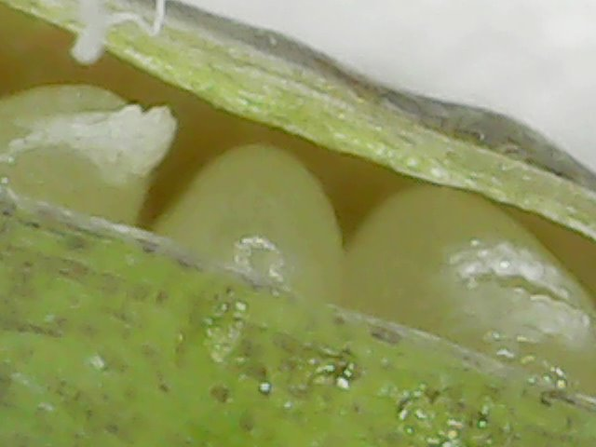

Figure 5. Legume example(?): Rock Harlequin. Right image is of the flower.

Figure 6. Example of needles

Figure 7. Inferior Ovary example: Northern Bedstraw

Figure 8. Syngenesious example 1: Pineapple Weed

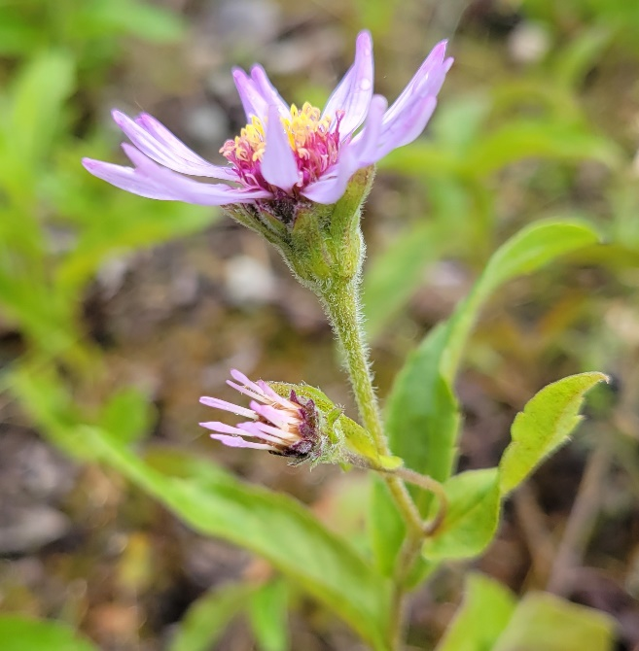

Figure 9. Syngenesious example 2: Siberian Aster.

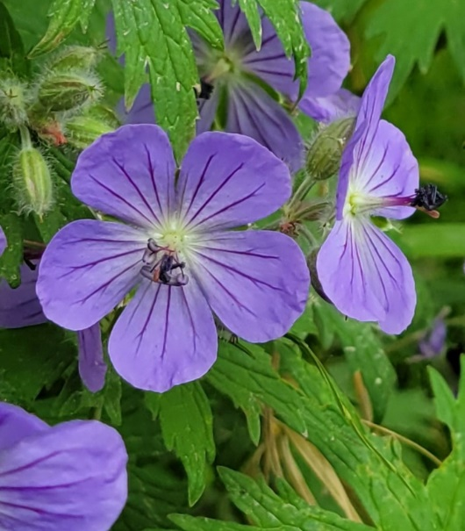

Figure 10. Actinomorphic example: Wolly Cranesbill.

Figure 11. Connation example: White Sweetclover. (Sympetalous?).

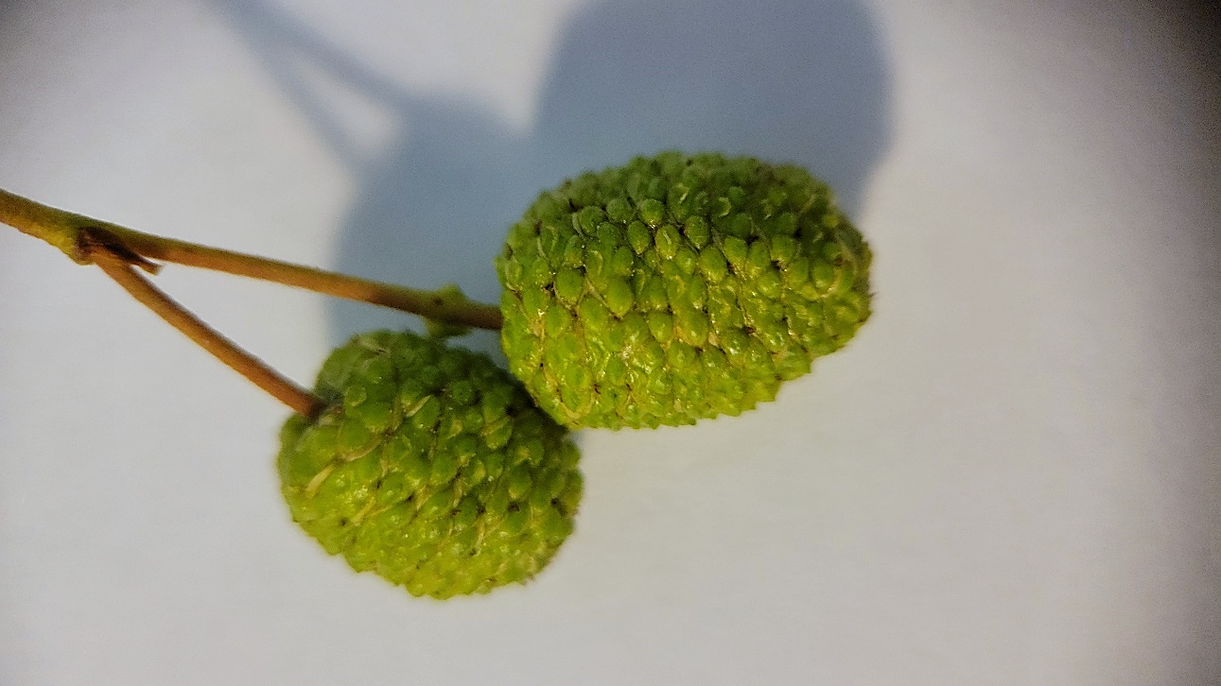

Figure 12. Example of connation (?): Aspen fruit(?). Bottom left: horizontal cross section. Bottom right: longitudinal cross section. Top right: magnified exterior.